Contents

About the project 1

Aim: 1

Technologies used: 2

Real world scenarios: 2

Resources used: 2

Resource Group: 2

Permissions to be set: 3

For Key Vault 3

For Storage Account 5

For Database Server 6

Dataset: 7

Process 8

Step 1: Creating the table to accommodate SalesData.csv in the database 8

Step 2: Configuring linked services , IR, and datasets 8

Create linked services and datasets 8

Deep dive into each linked service and datasets 10

Create Integrated runtime 13

Step 3: Creating pipeline for git to sql database transfer [Copy Data Activity] 15

Step 3: Creating an incremental pipeline 17

Step 4: Creating databricks resources 28

Errors and resolutions 39

# About the project

Aim: The aim of the project is to get the data from SQL Server and github via ADF pipelines and transform it using databricks using medallion architecture. Also, handle incremental data SCD type 1 (Upsert)

Technologies used: Azure Data Factory, Databricks, and PySpark. Delta Lake and Delta Tables for efficient data storage and processing, Medallion architecture to structure your data pipeline effectively

Real world scenarios: Dimensional Data Modeling and Slowly chanding dimesntions Type 1 (Incremental load)

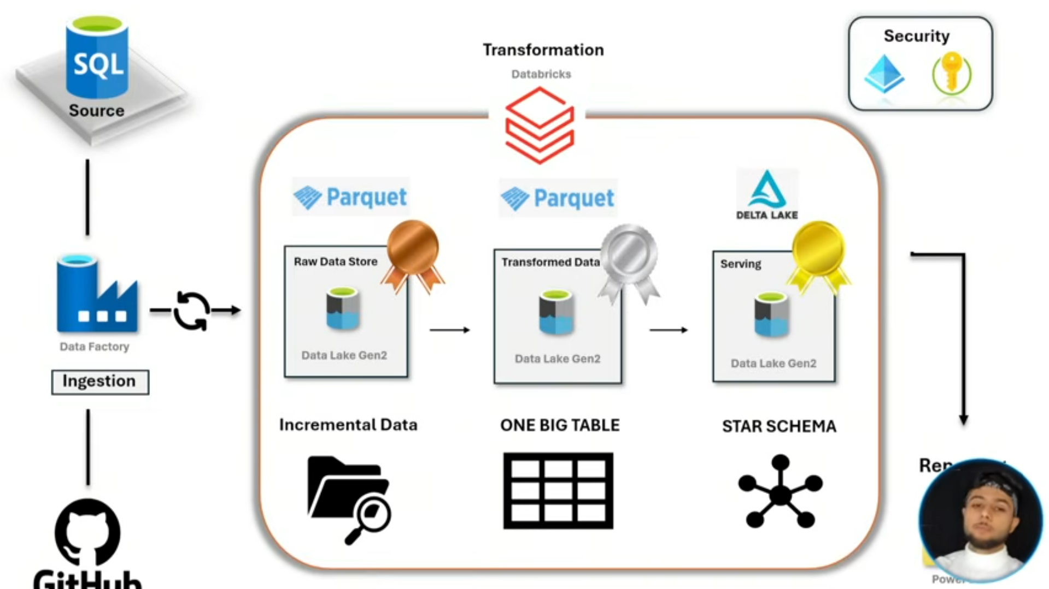

# Resources used:

Resource Group: **rg_car_sales**

* + SQL Server: carsalesserver25
    - SQL Database: **carsales (carsalesserver25/carsales)**
  + Databricks notebook: dbricks_carsales
  + Azure Data factory: dfcarsales
  + Storage Account: sacarsales25 [ the storage account created is ADLS Gen 2 by simply enabling ‘Hierarchical namespace’ while configuration.

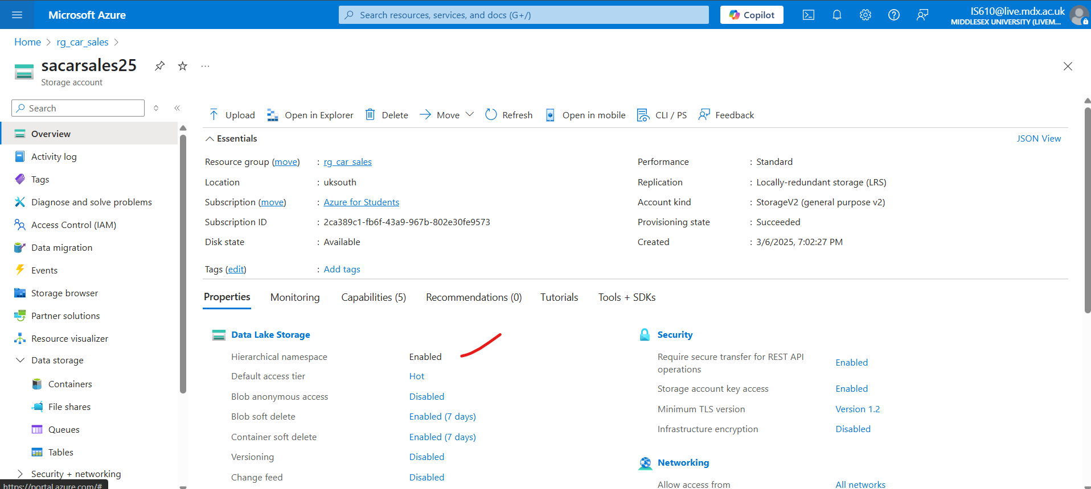

* + Key Vault: kvcarsales

**All the resources were made in the same ‘Region’**

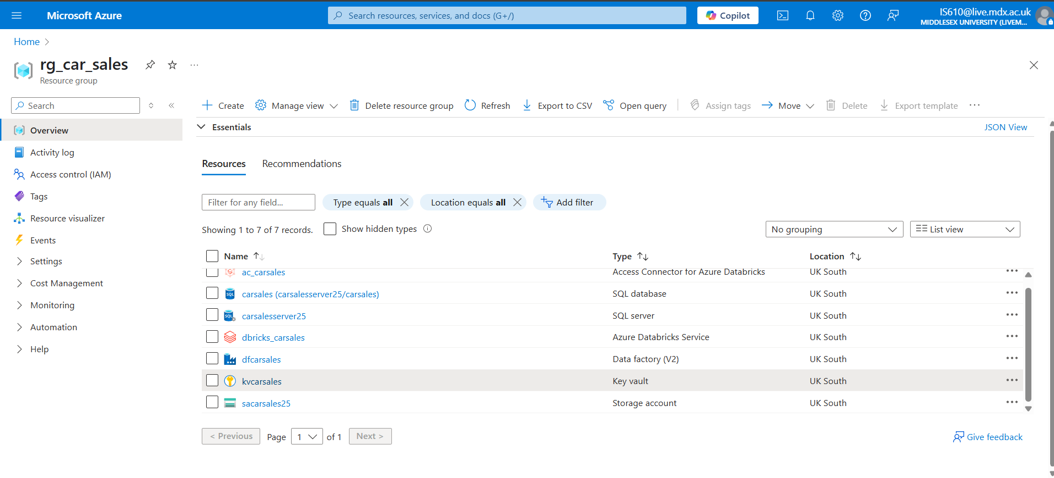

# Permissions to be set:

## For Key Vault

Go to Key Vault 🡪 Access Control(IAM) 🡪 Add 🡪 Add role assignment

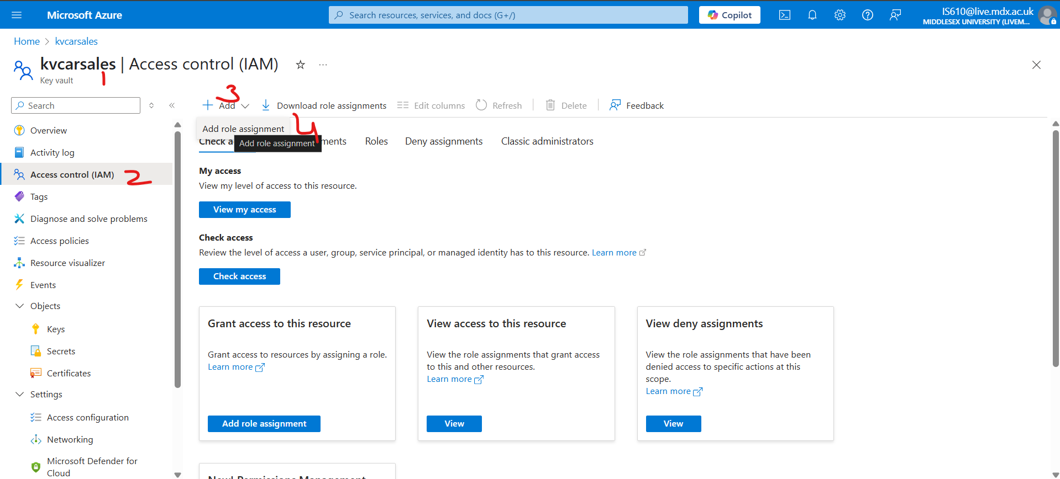

Assign key vault administrator role

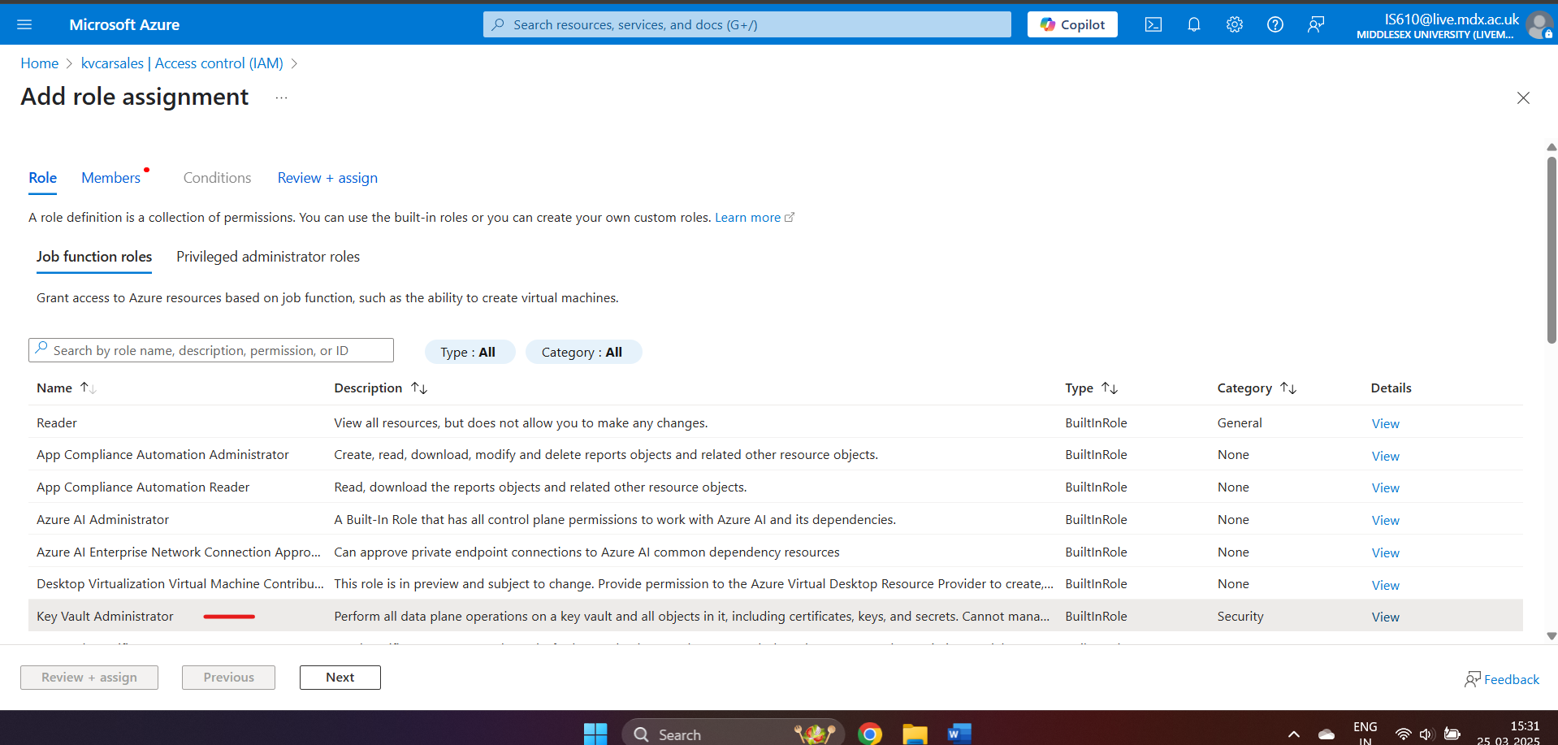

Click Next in the above screenshot and then choose user, groups or service principles and choose the members and then clock on Select as per below sreenshot. Click Next and this is done.

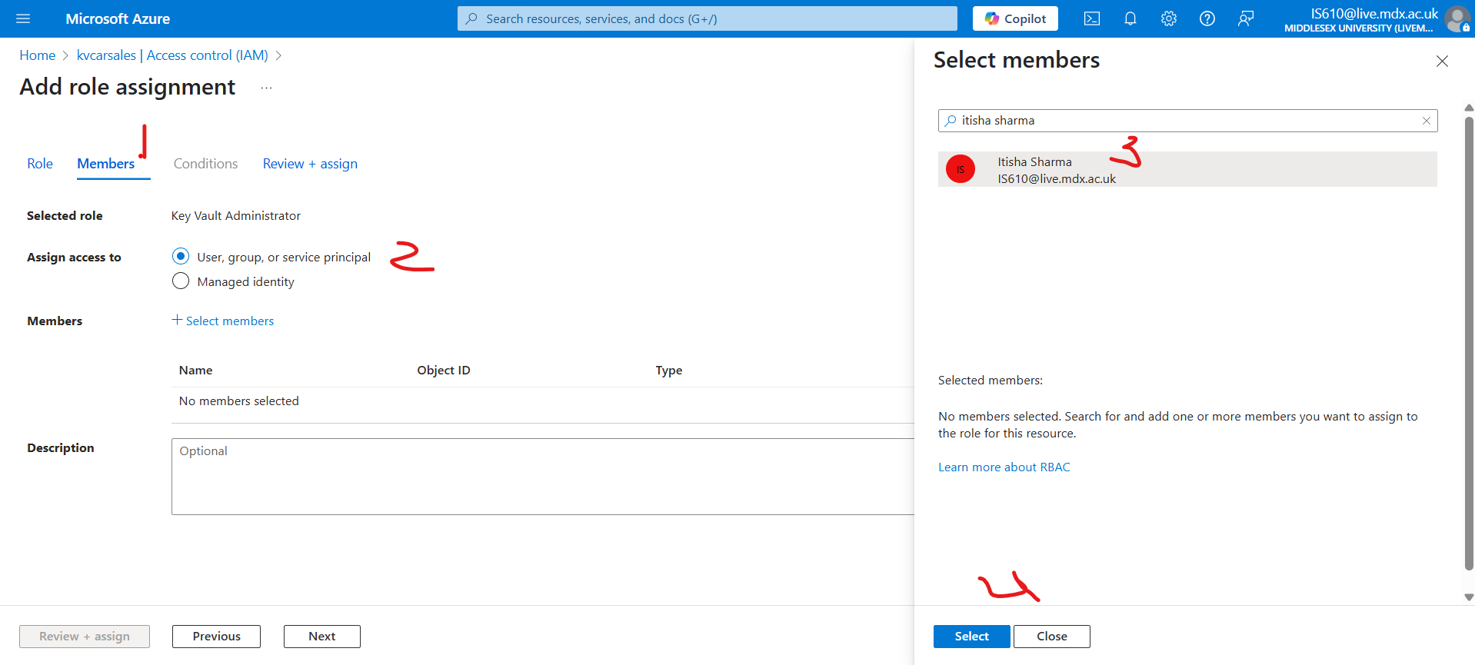

To check the access rights ,

Resource group🡪 Key vault 🡪 Access Control (IAM) 🡪 View my access

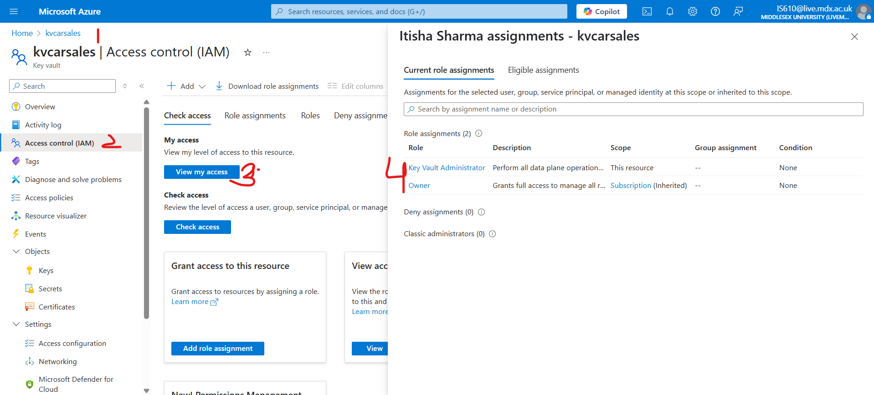

## For Storage Account

Similarly assign ‘Storage Blob Contributor’ to the data factory resource ‘dfcarsales’ within Storage accounts so that it can put the refined data in the storage account.

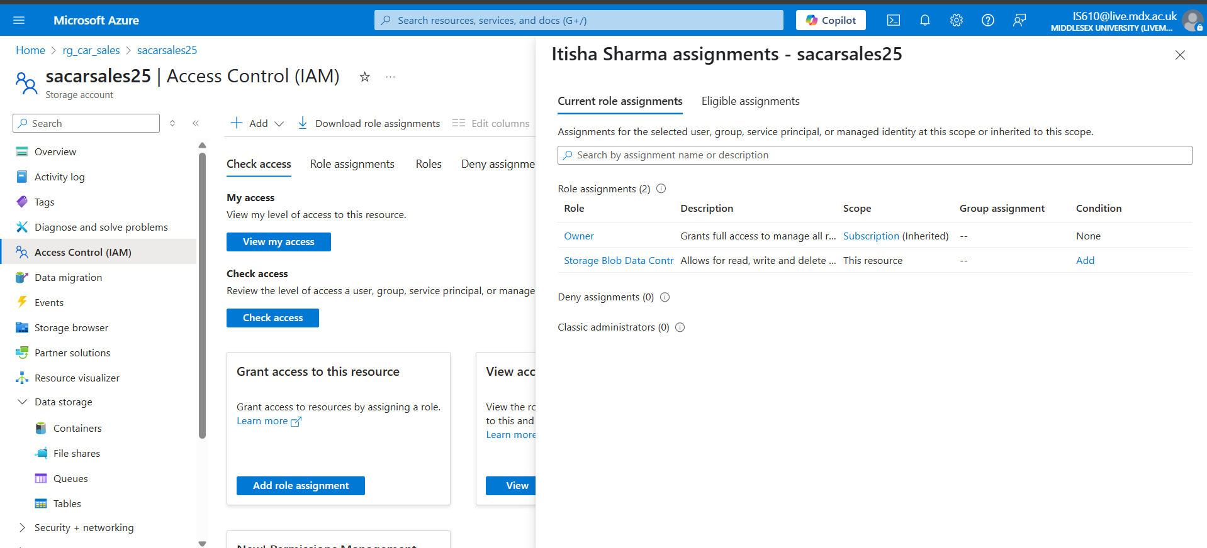

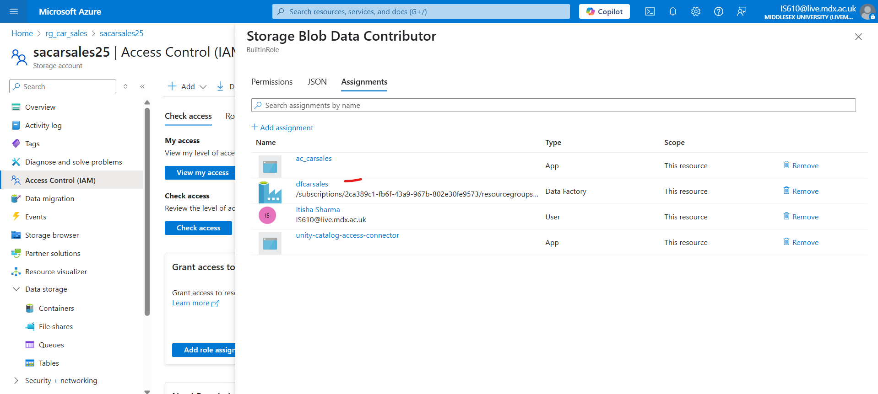

## For Database Server

Not every service can access the database, therefore Go to Resource Group 🡪 SQL Server 🡪 Security 🡪 Networking 🡪 and enable ‘Allow Azure services and resources to access this server’

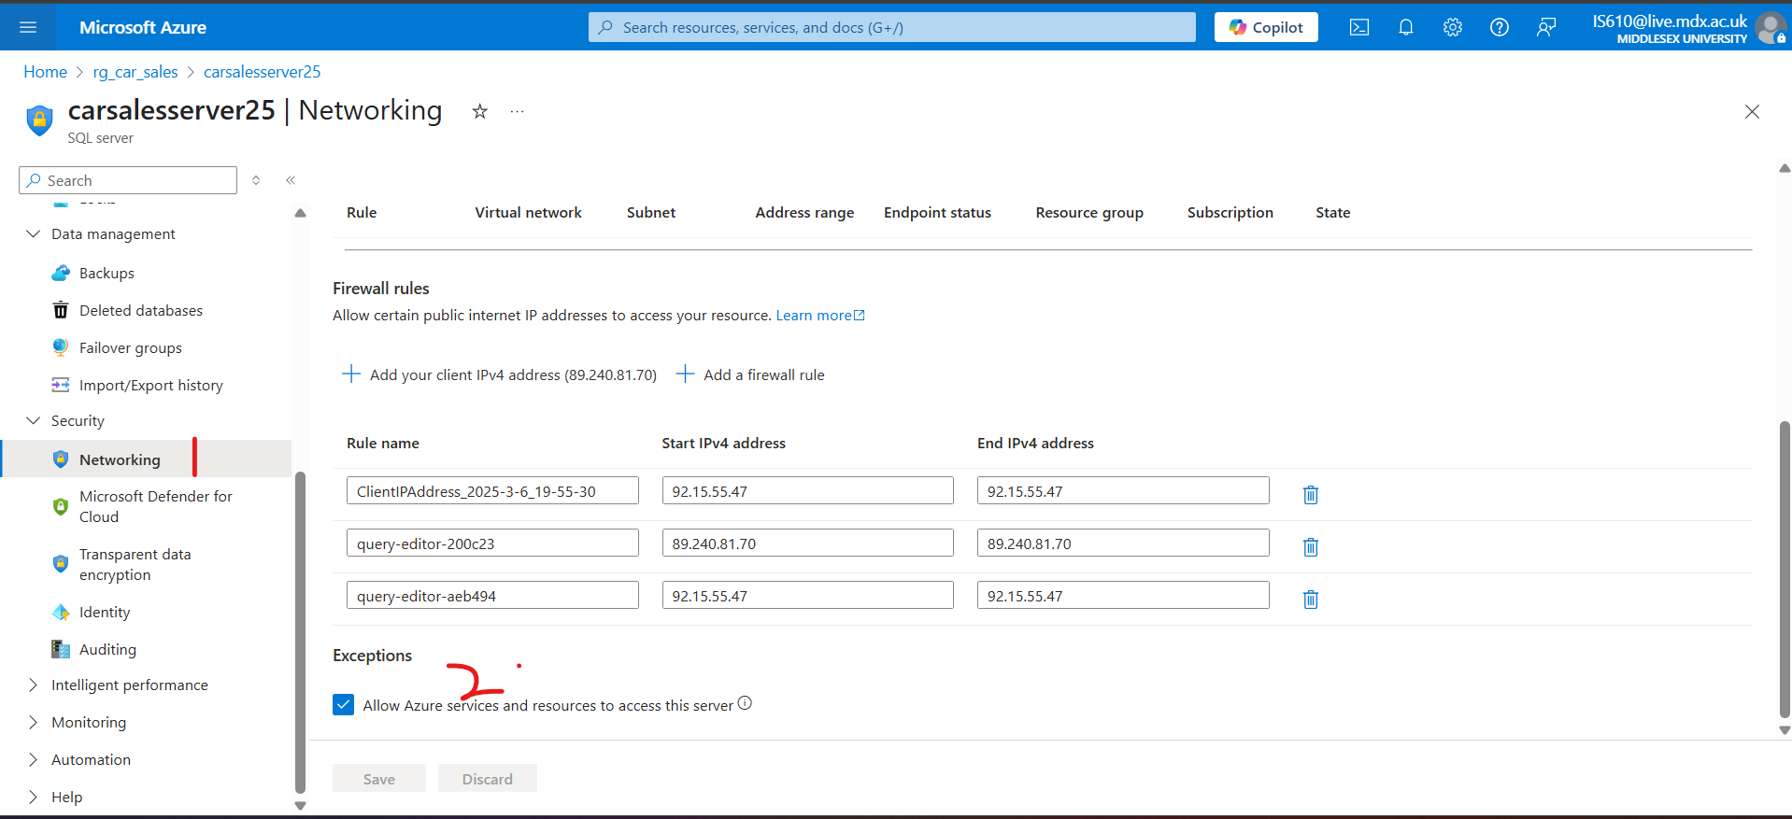

# Dataset:

Dataset source link: <https://github.com/itisha89/adf_carsales>

It has 2 files – SalesData.csv (for initial load) and IncrementalSales.csv (for incremental load).

The SalesData.csv looks like as below screenshot

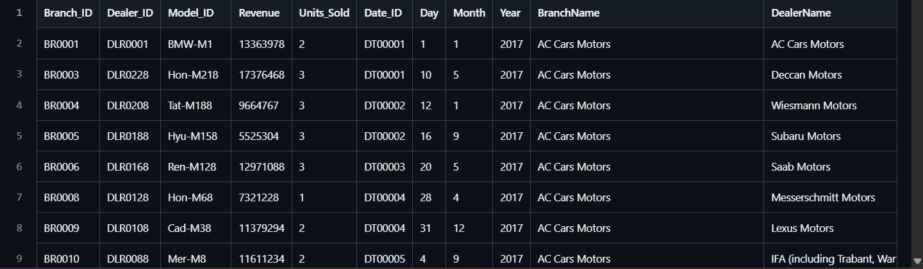

Base and relative URL

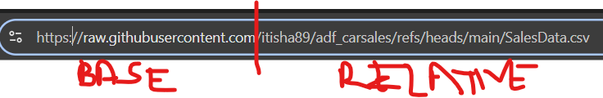

# Process

## Step 1: Creating the table to accommodate SalesData.csv in the database

Here, we are making the source destination of our data

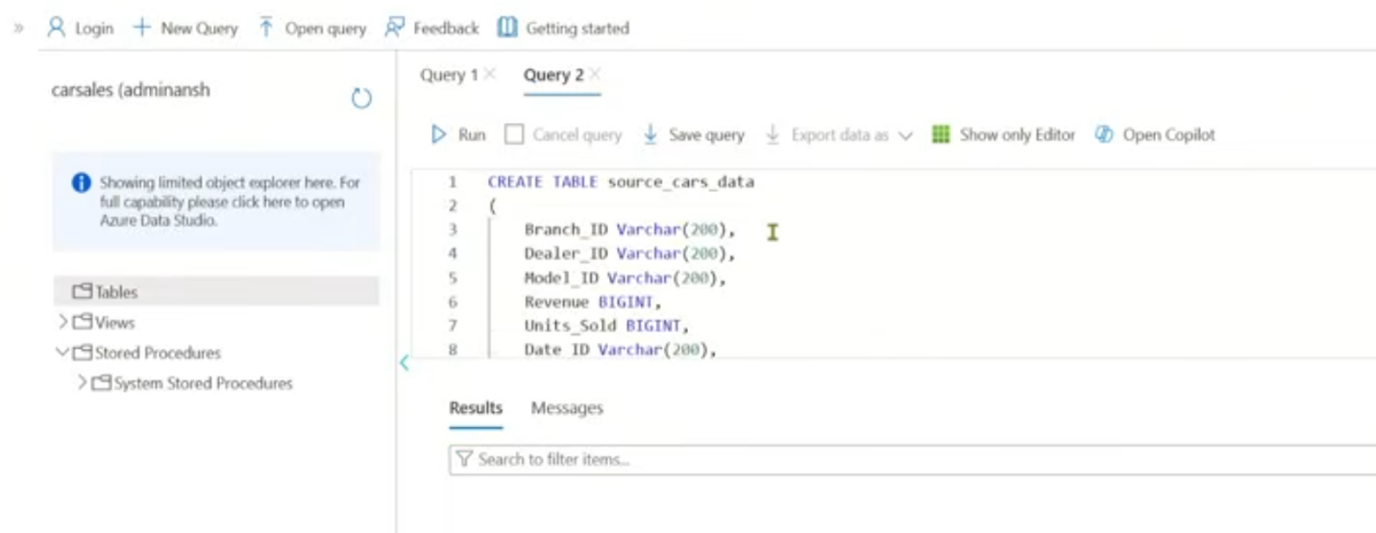

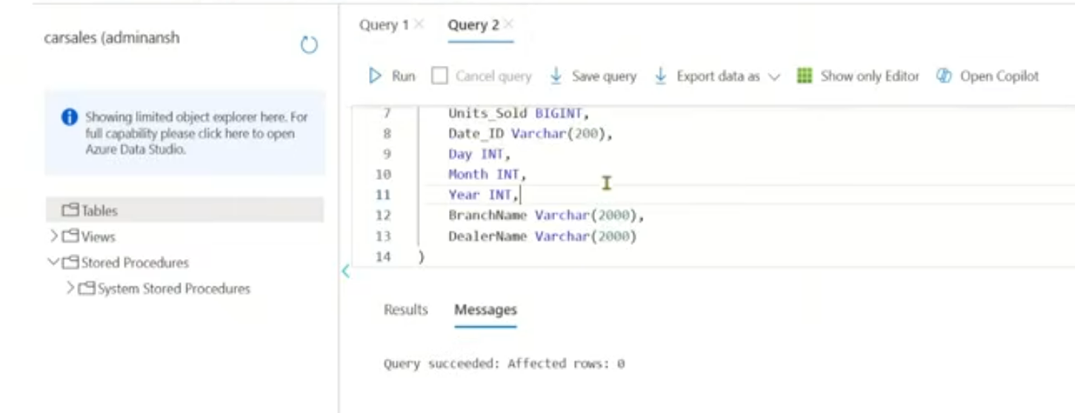

## Step 2: Configuring linked services , IR, and datasets

### Create linked services and datasets

To create the pipeline [copy_git_to_sqldb] , we need to create appropriate datasets [ds_AzureSqlTable1, ds_git] , linked services [ls_AzureSqlDatabase1, ls_git].

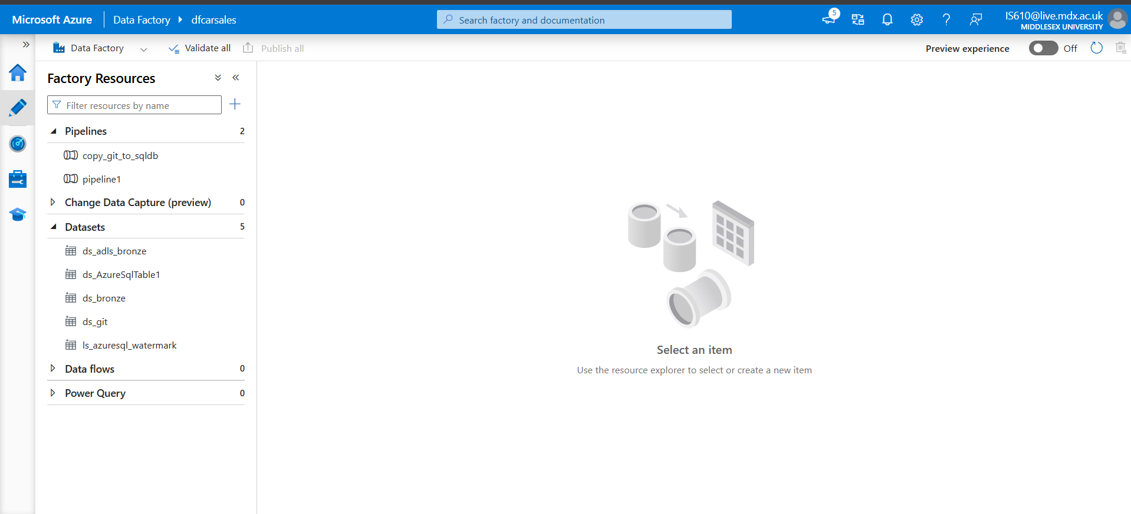 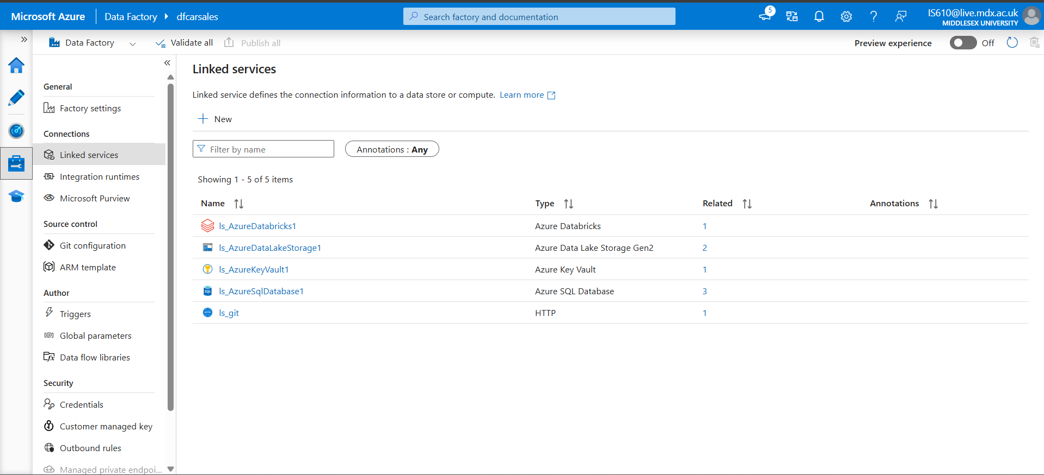

### Deep dive into each linked service and datasets

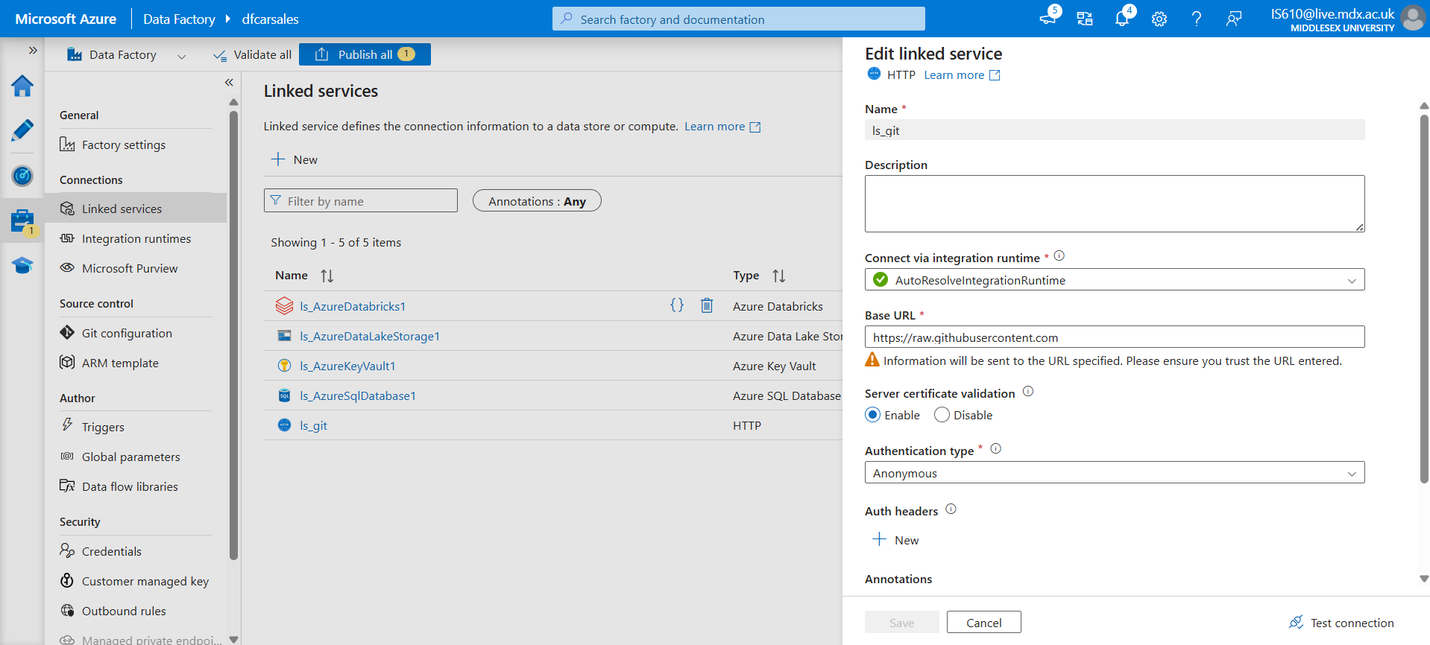 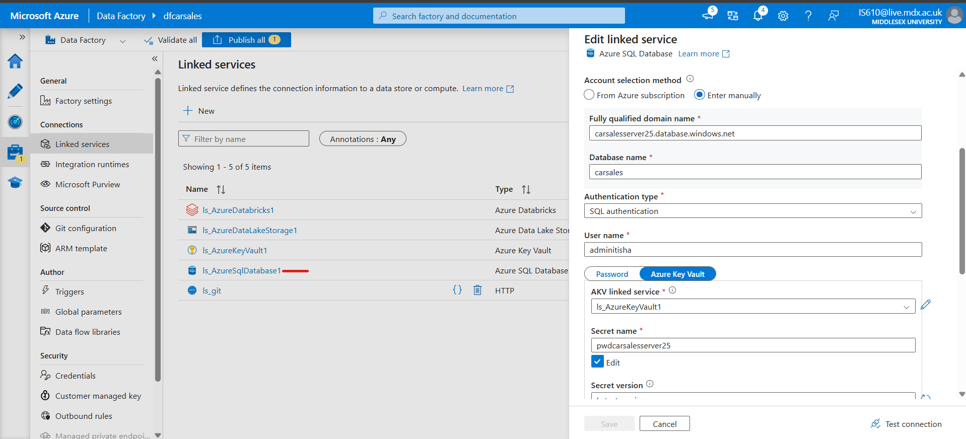 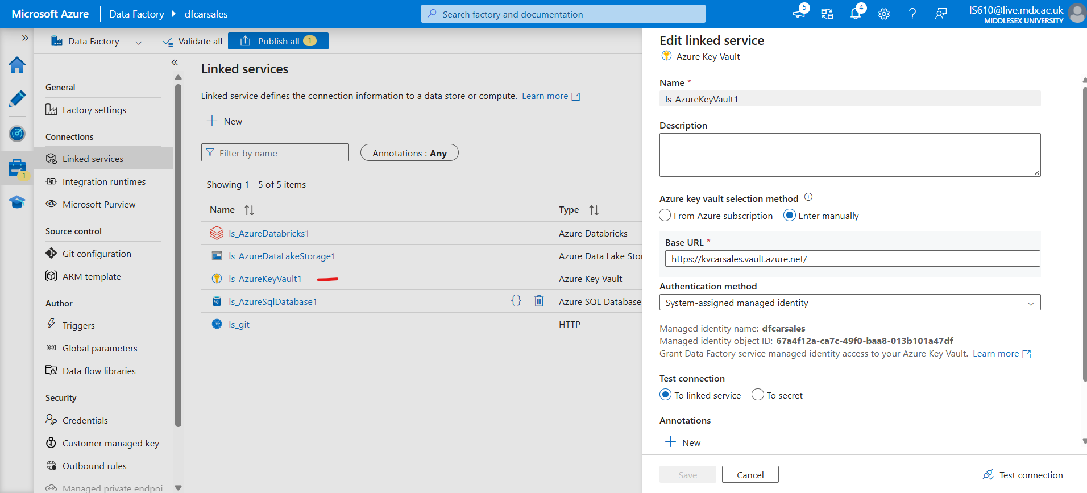 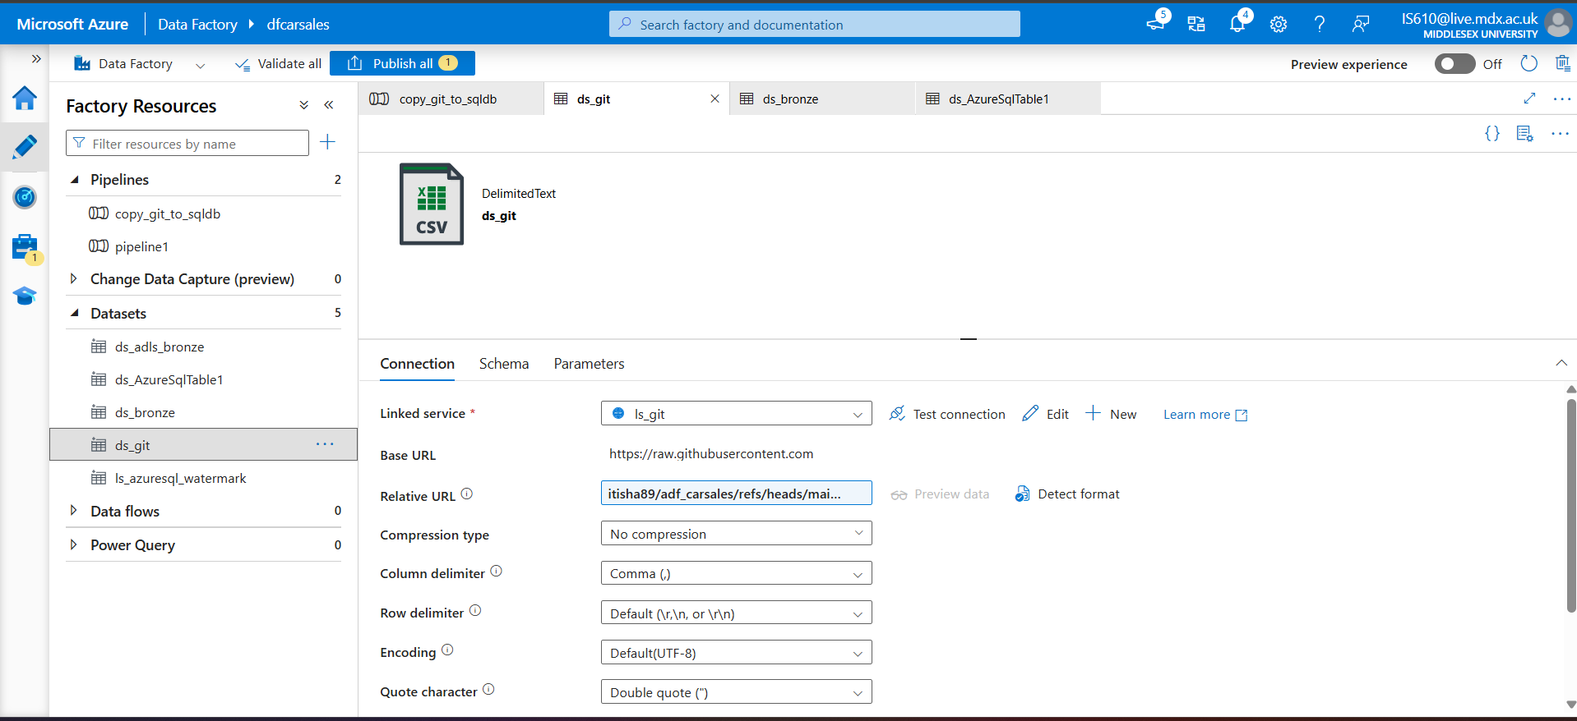

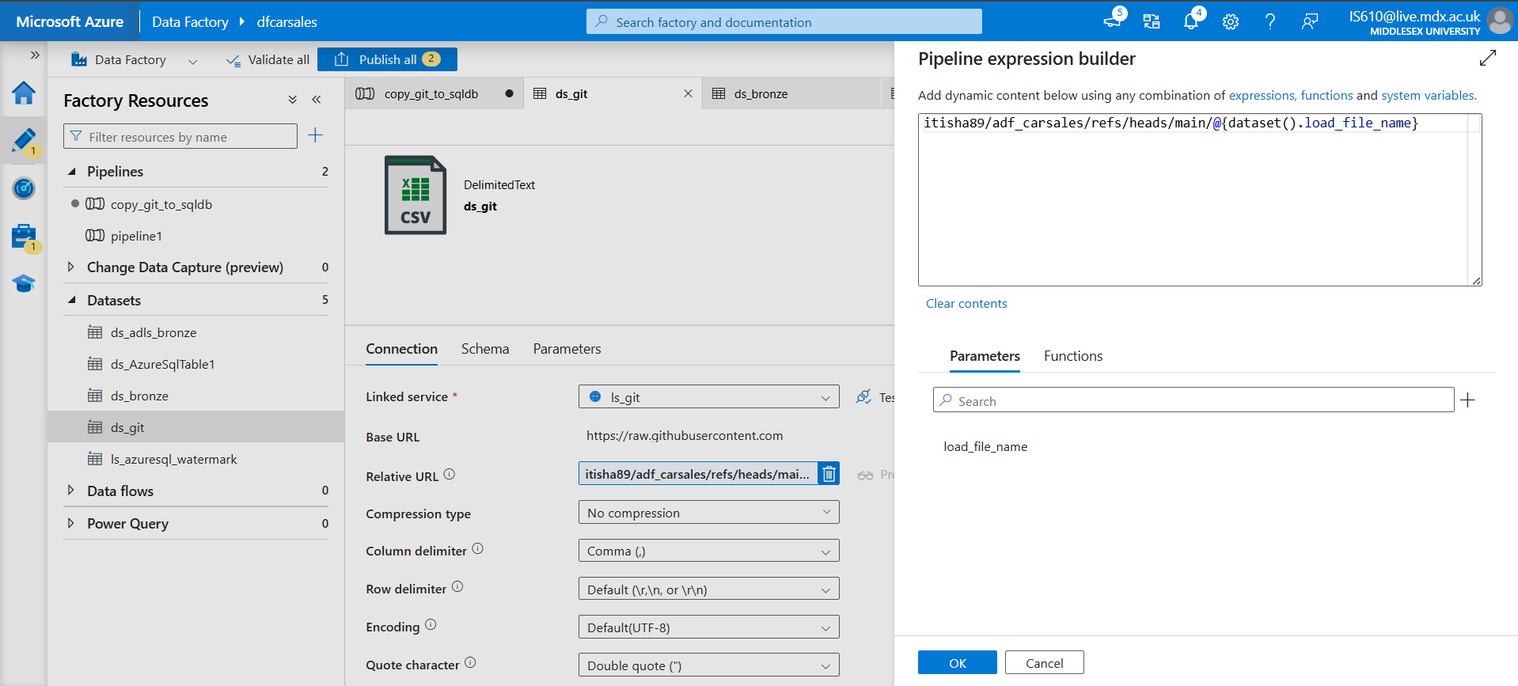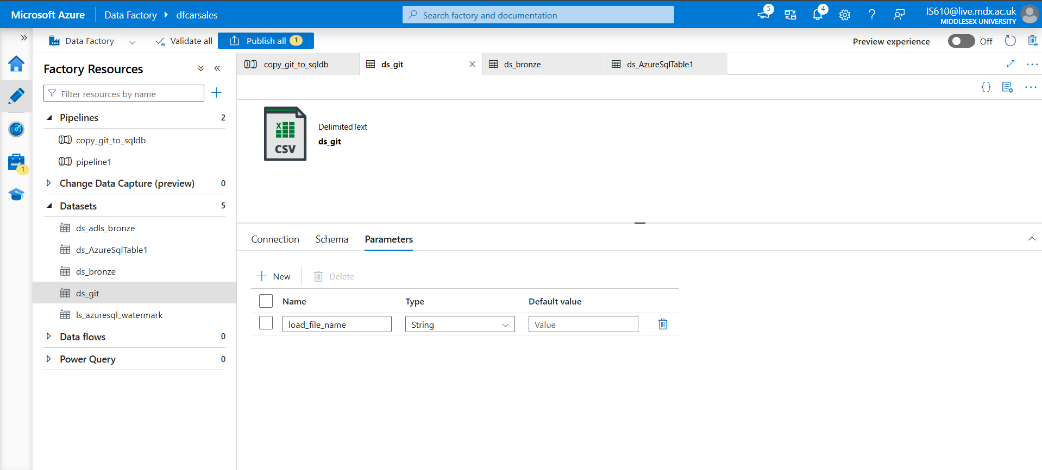

While creating [ds_git], we need to give the relative URL and we make it dynamic by creating parameter [load_file_name] as we need to process 2 files (1 for iniitla load and 1 for incremental load) and only the file name changes. Therefore we parameterize filename.

Make sure to put the parameters in parenthesis as the value inside that parameter is the what we need.

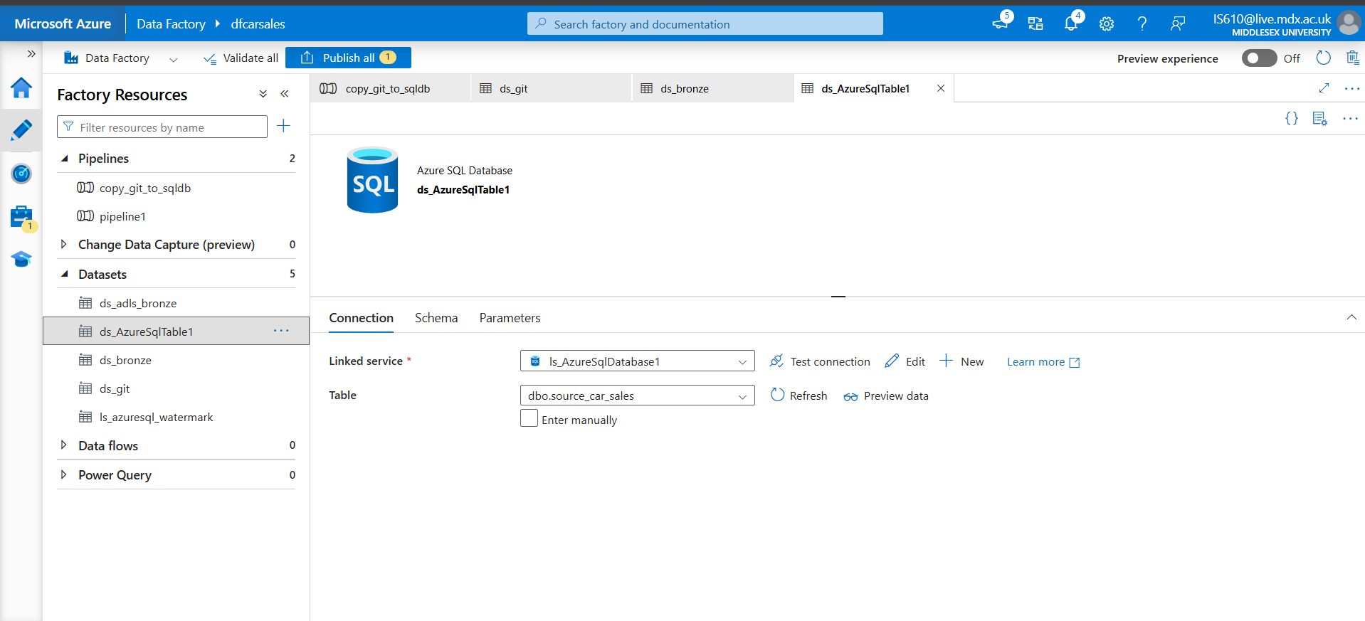

### Create Integrated runtime

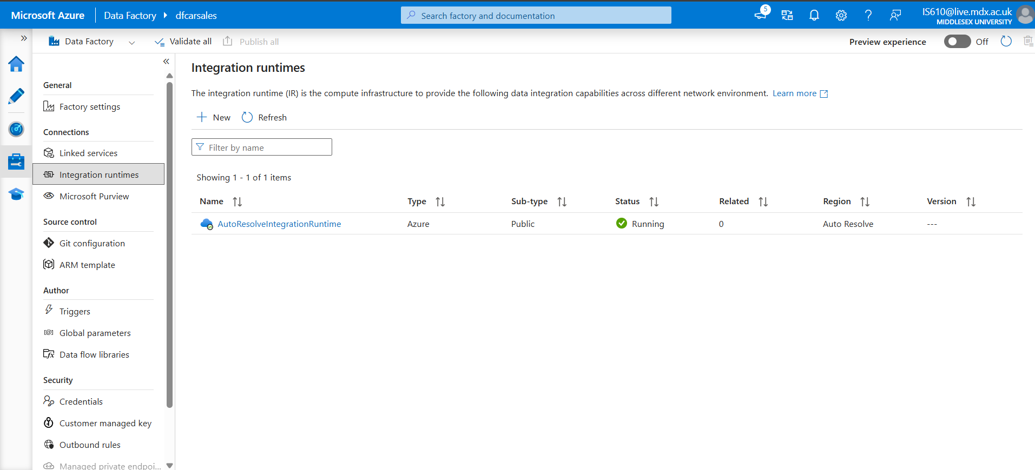

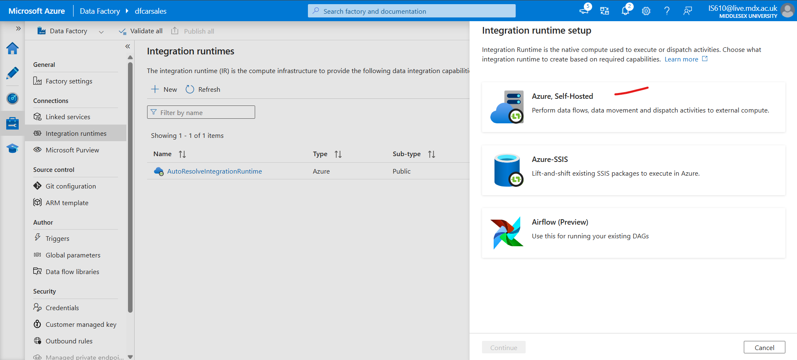 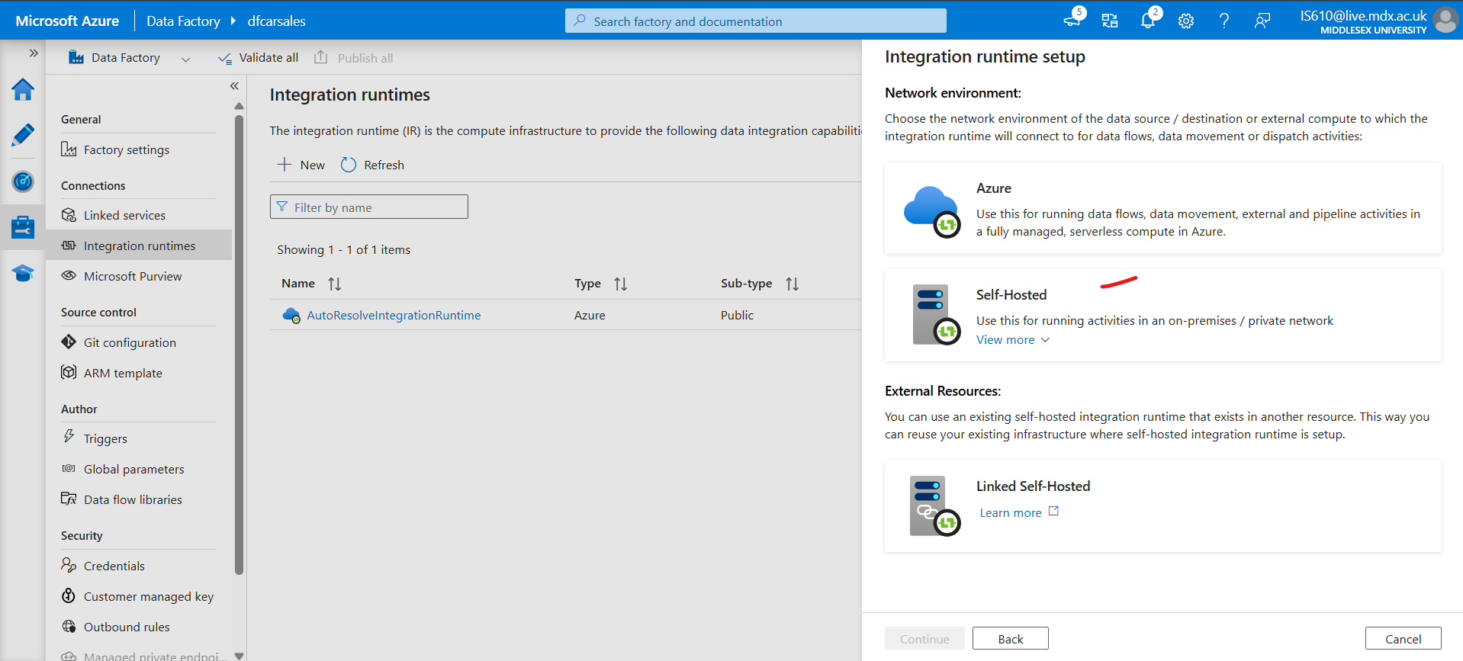 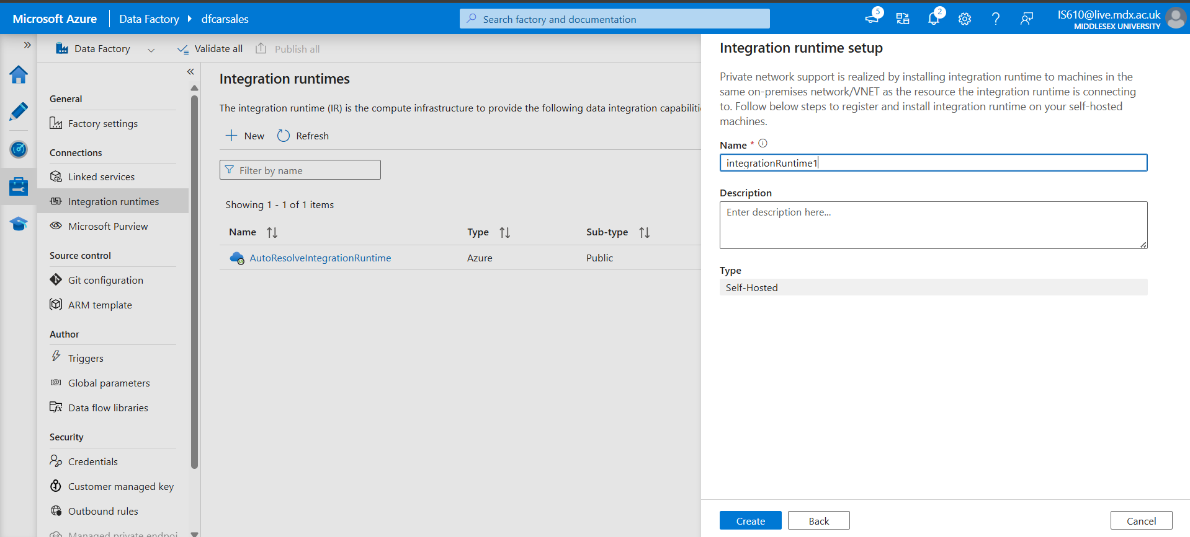

Once it is created, use either the manual or automatic setup

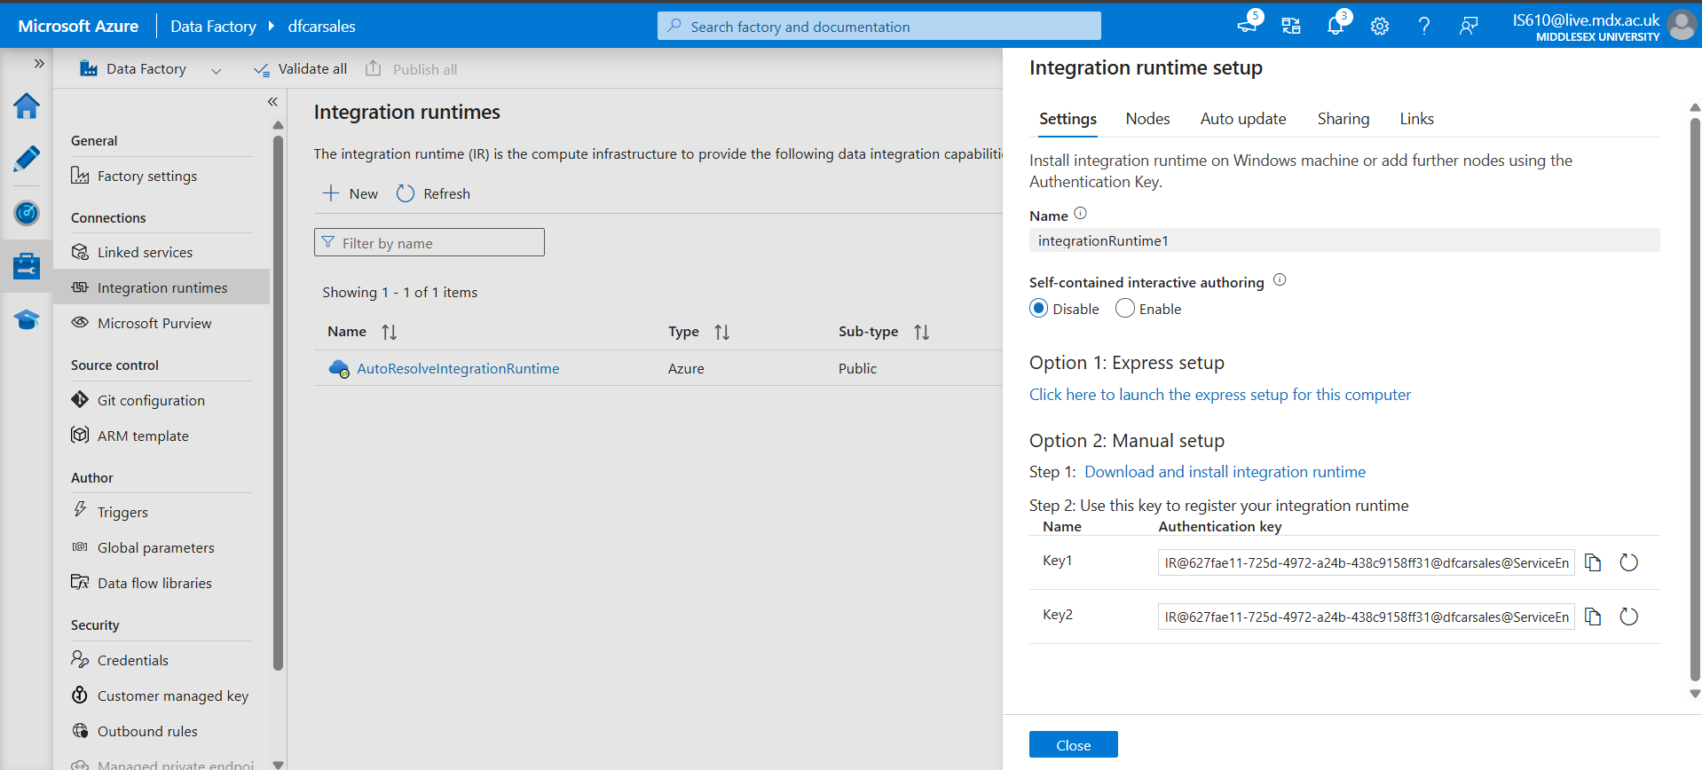

## Step 3: Creating pipeline for git to sql database transfer [Copy Data Activity]

Create a new pipeline [copy_git_to_sqldb] and from move and transform section drag and drop copy data activity to the canvas.

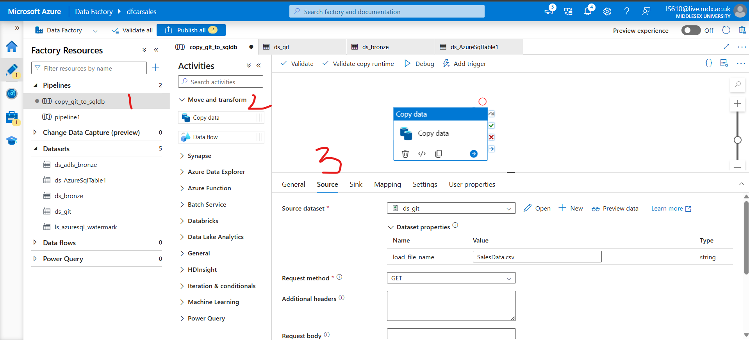

In the parameter [load_file_name] pass the value of the filename. Here in our case its [‘SalesData.csv].

Configure the [Sink], here it is the SQL database. Add linked services to this.

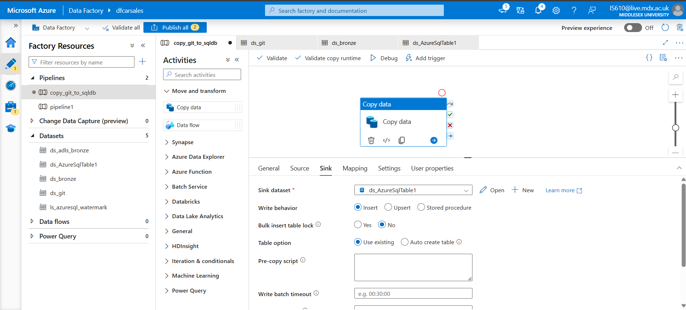

And then [Debug] the pipeline. Once u click on [Debug], the status of the pipeline can be seen here

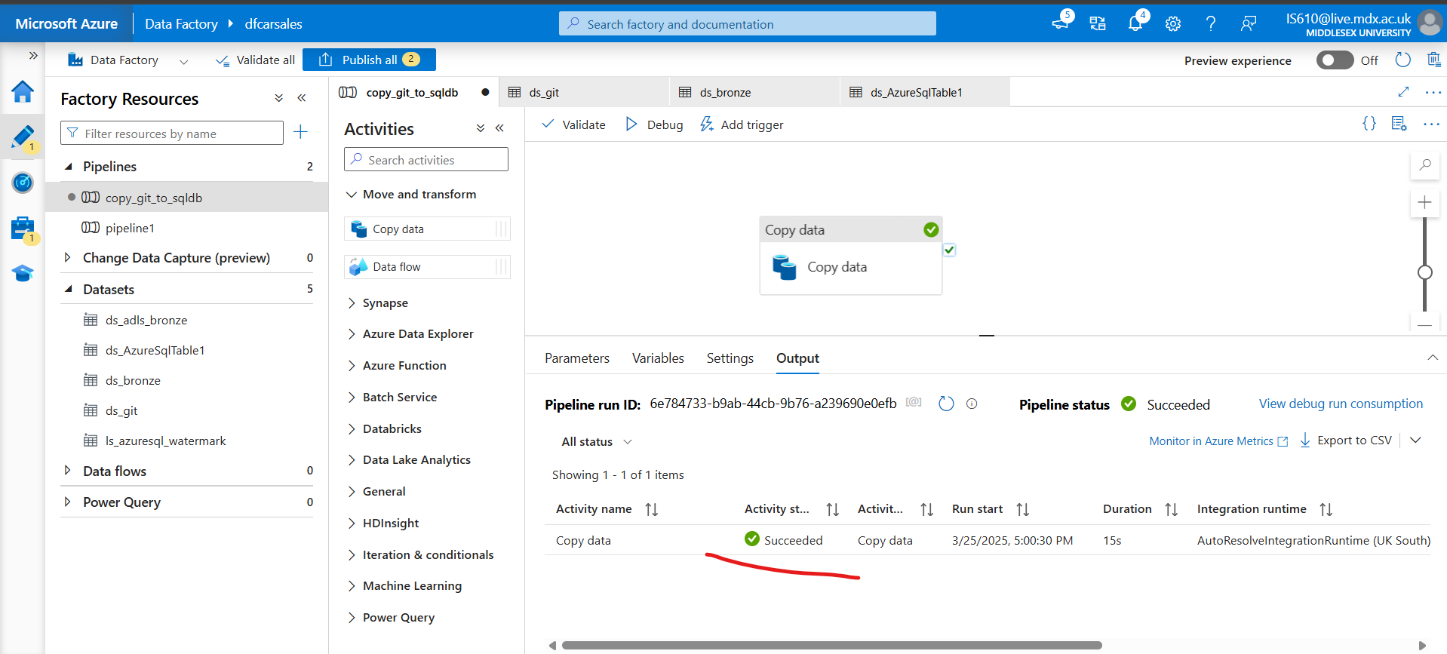

To check if the file has been loaded into the SQL database.

Go to Resource Group 🡪 SQL Database 🡪 Query editor 🡪 Enter the password 🡪 Query the table

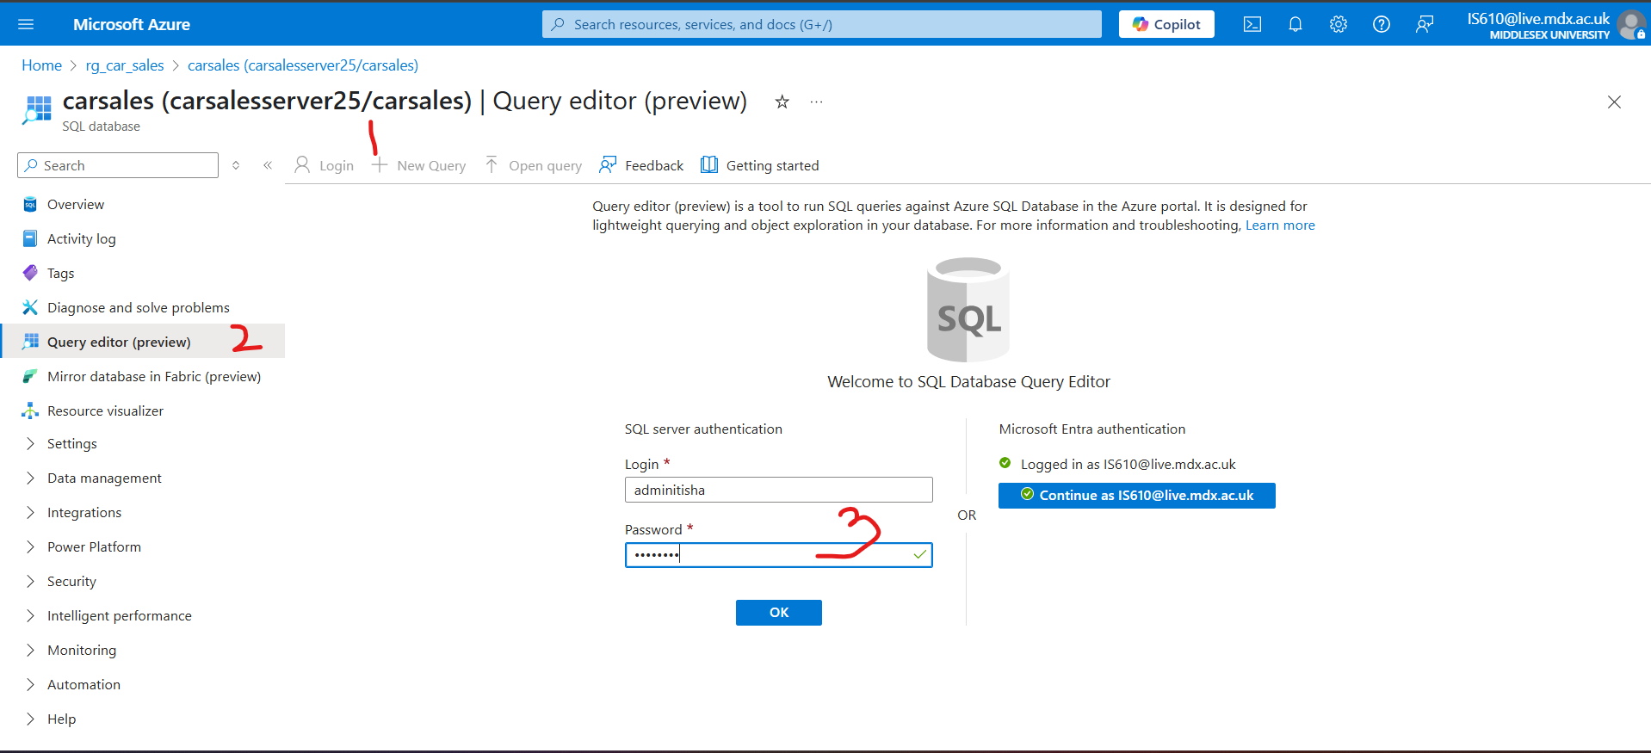 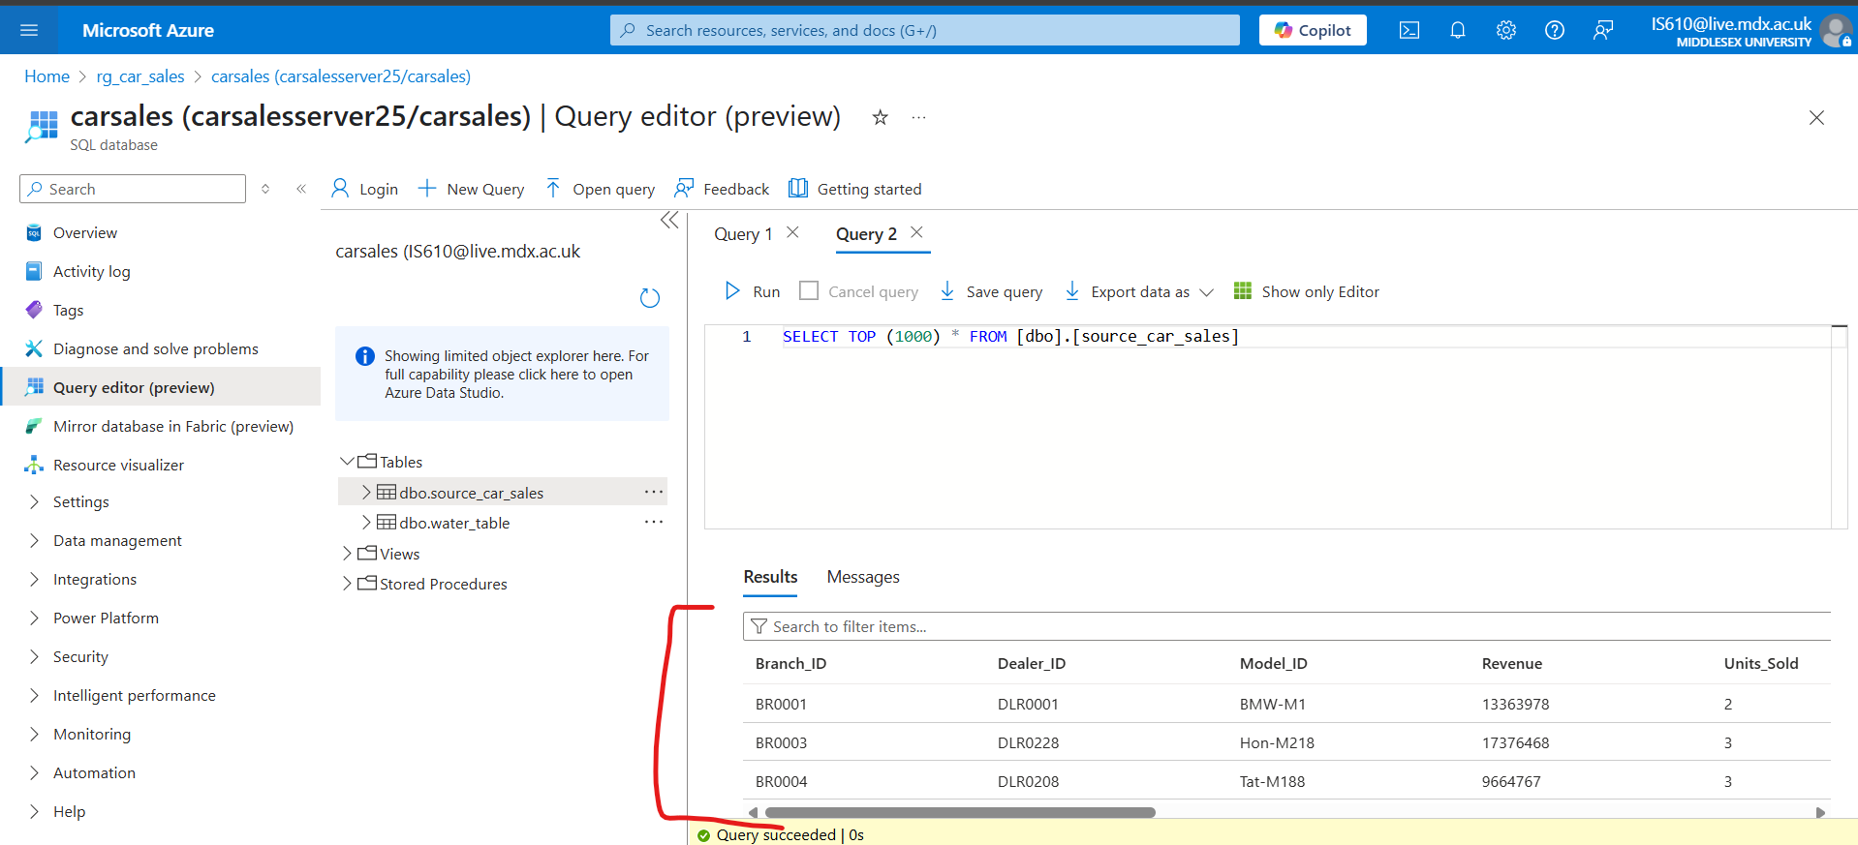

## Step 3: Creating an incremental pipeline

* Create lookup activity to lookup the max date values in the current load and watermark table
* Create copy activity to copy incremental load
* Update the watermark table using stored procedure

Here we need [ls_azuresql_watermark], [ds_AzureSqlTable1 ], [ds_adls_bronze],[   
ls_AzureDataLakeStorage1], [ls_AzureSqlDatabase1].

We will create a watermark table in the SQL database which will store the last load date. It will have only 1 column – [last_load].

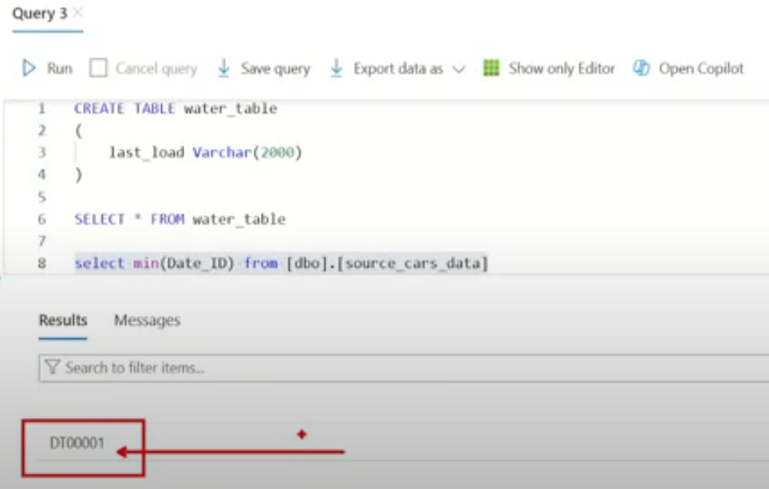

Inserting the date in water_table

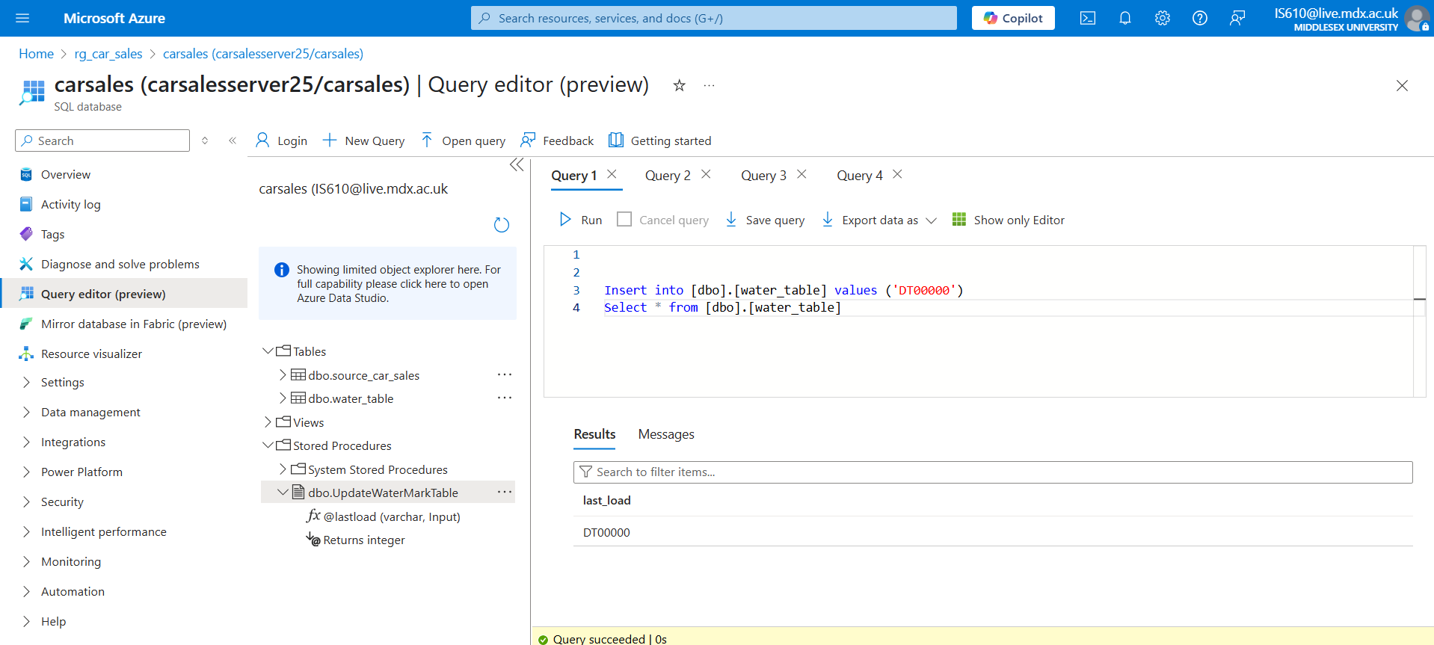

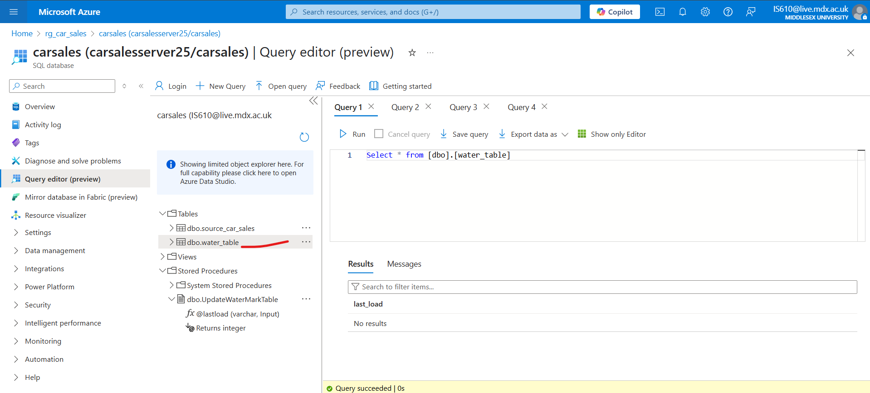

Now in the pipeline we will create 2 lookup activities [LKP_last_load] and [LKP_currentload]. The [LKP_last_load] will check the values from the [water_table] using the SQL query [Select * from water_table]

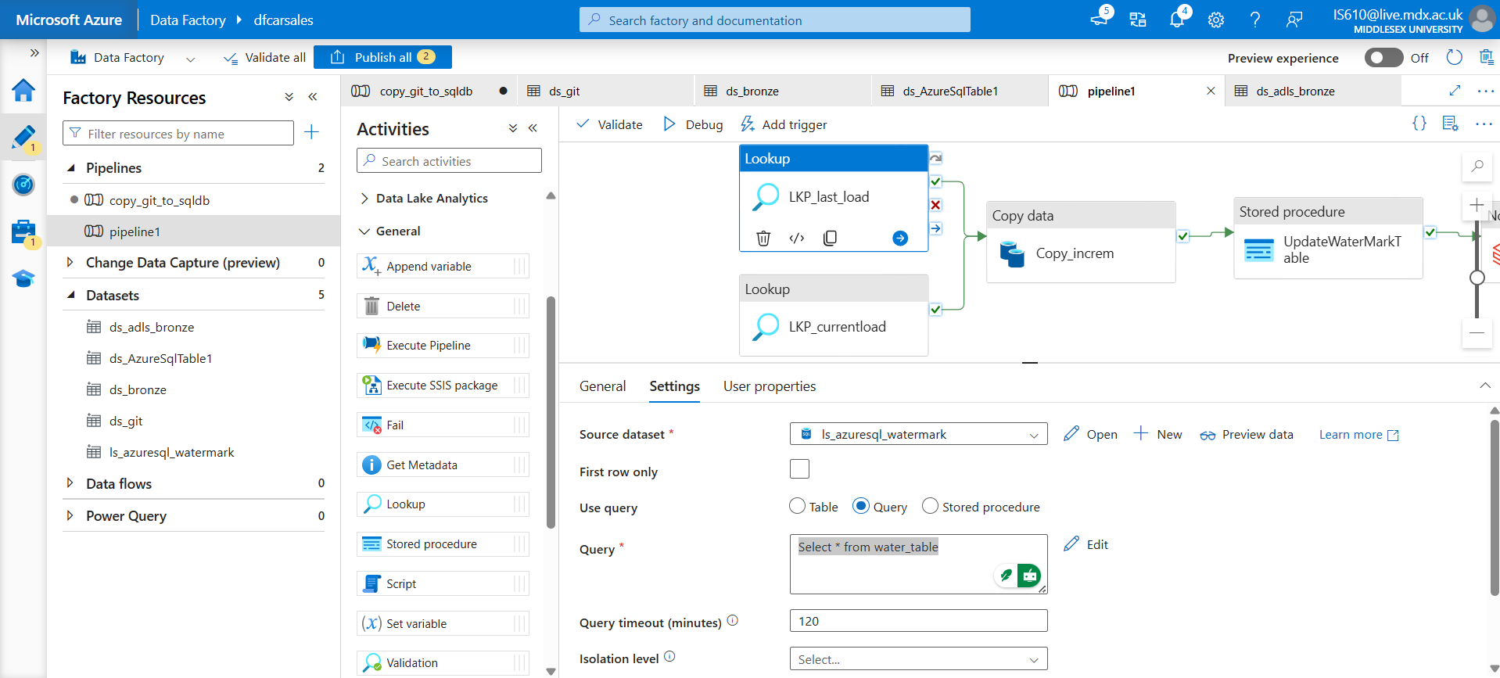

The [LKP_currentload] will check the maximum date from [source_car_sales] table using SQL query [Select max(date_id) as max_date from source_car_sales].

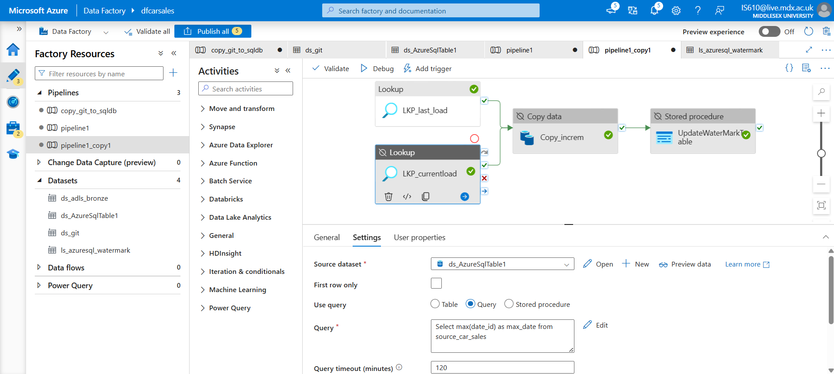

For copy activity use source as [ds_AzureSqlTable1] with SQL query as [Select * from source_car_sales where date_id > '@{activity('LKP_last_load').output.value[0].last_load}' and date_id <= '@{activity('LKP_currentload').output.value[0].max_date}']

Sink as : [ds_adls_bronze]

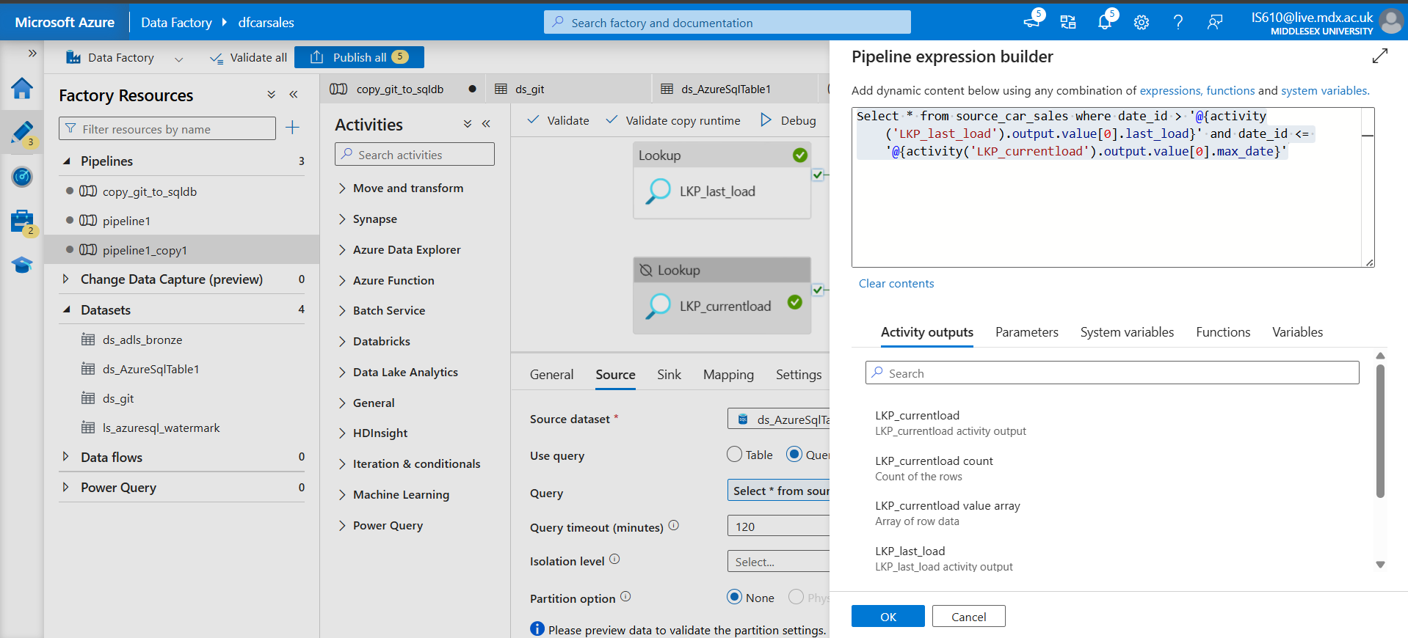

For stored procedure – create one in the database

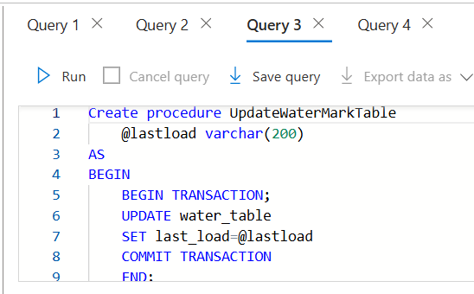

Here the parameter is [lastload] which would be passed to this stored procedure via the pipeline. Configure the stored procedure as follows.

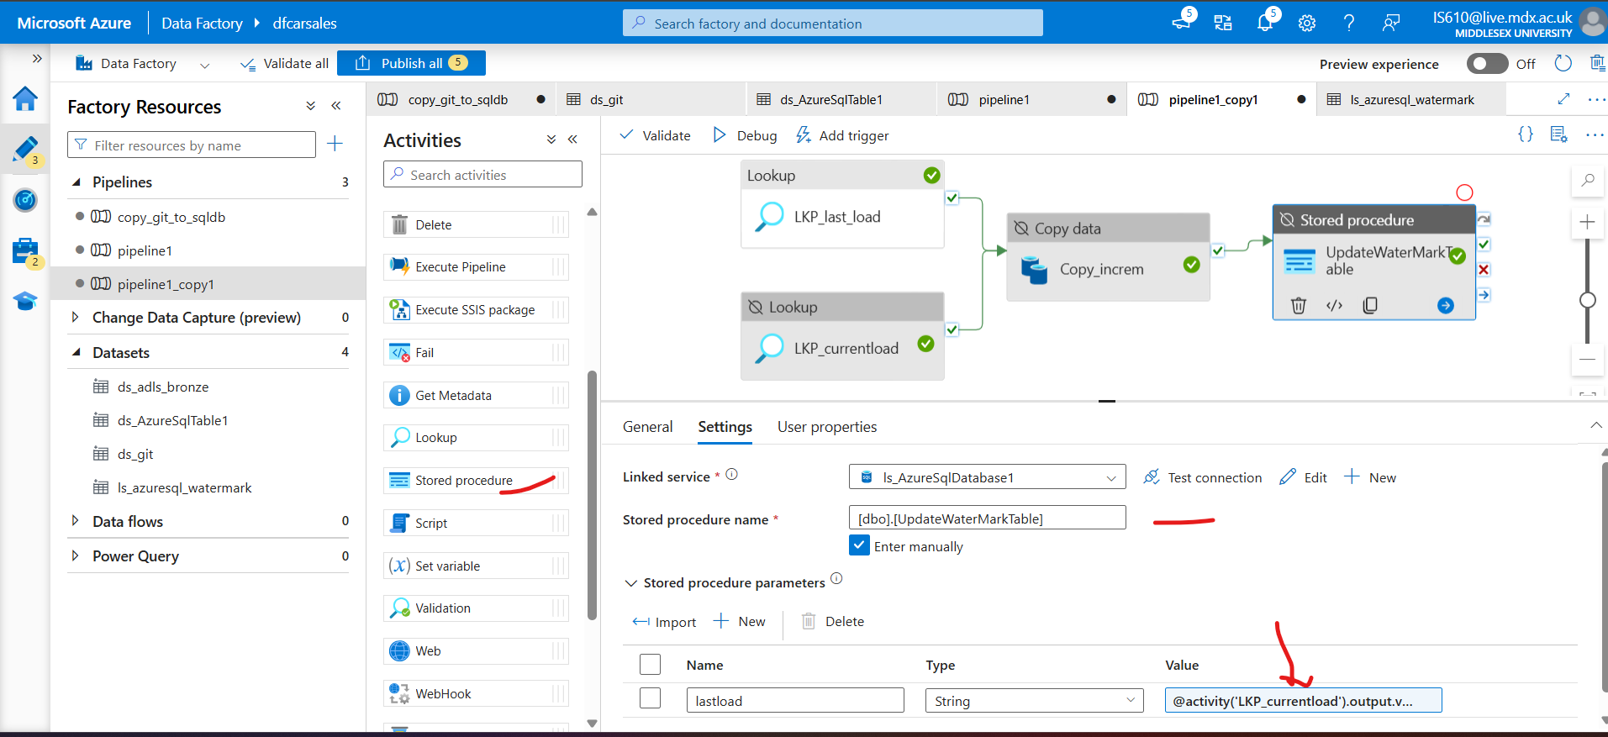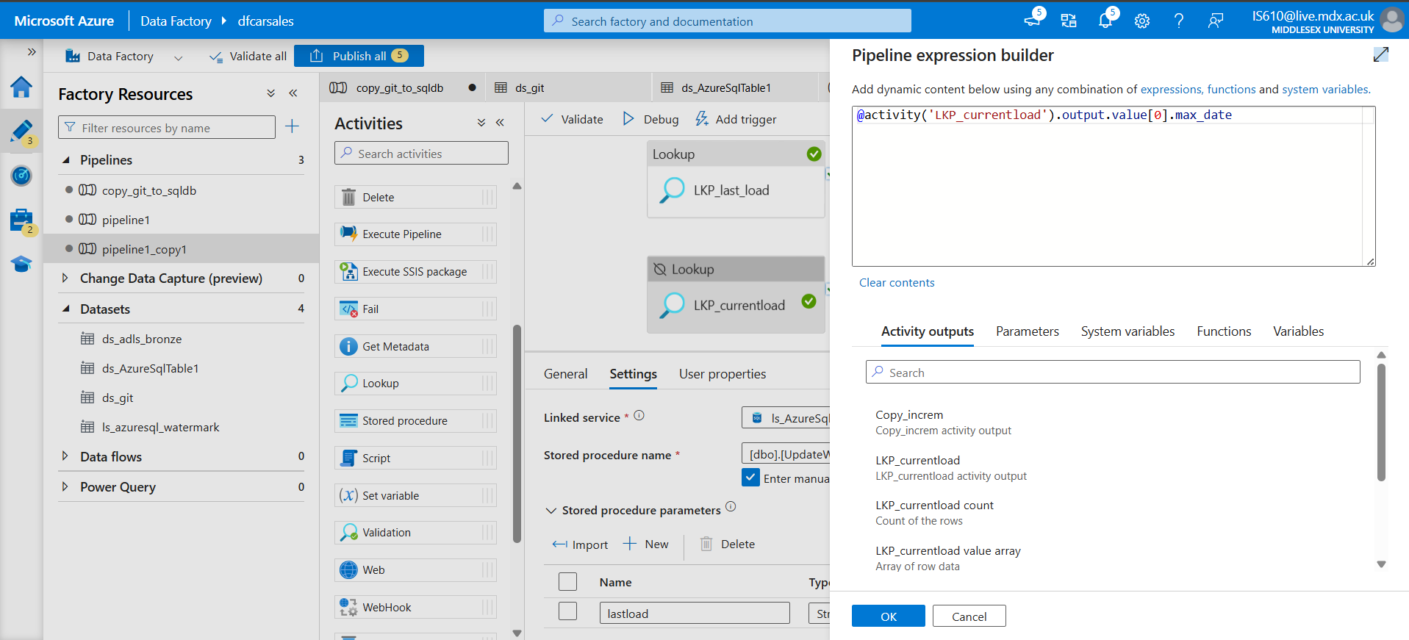

Run this pipeline.

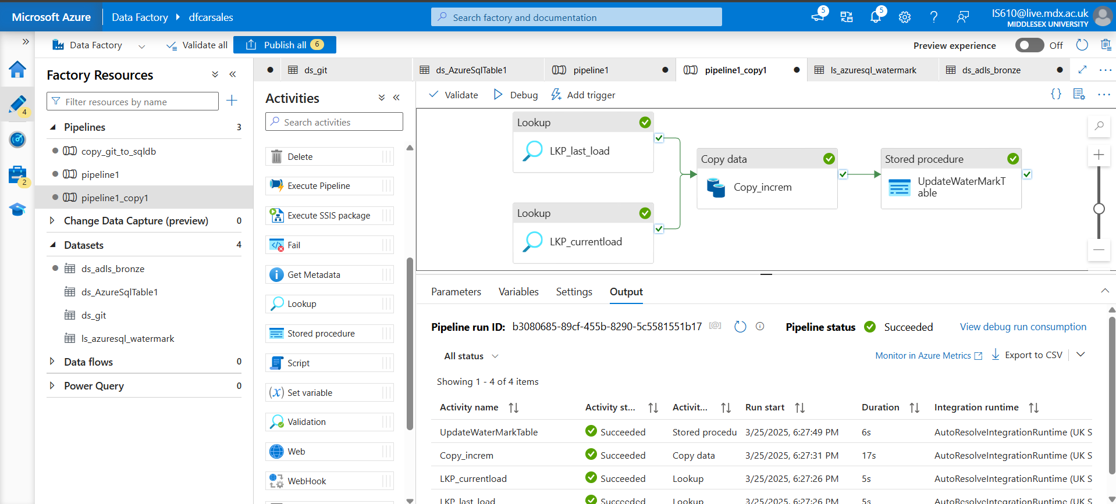

Now the data is in the ADLS bronze folder as shown below

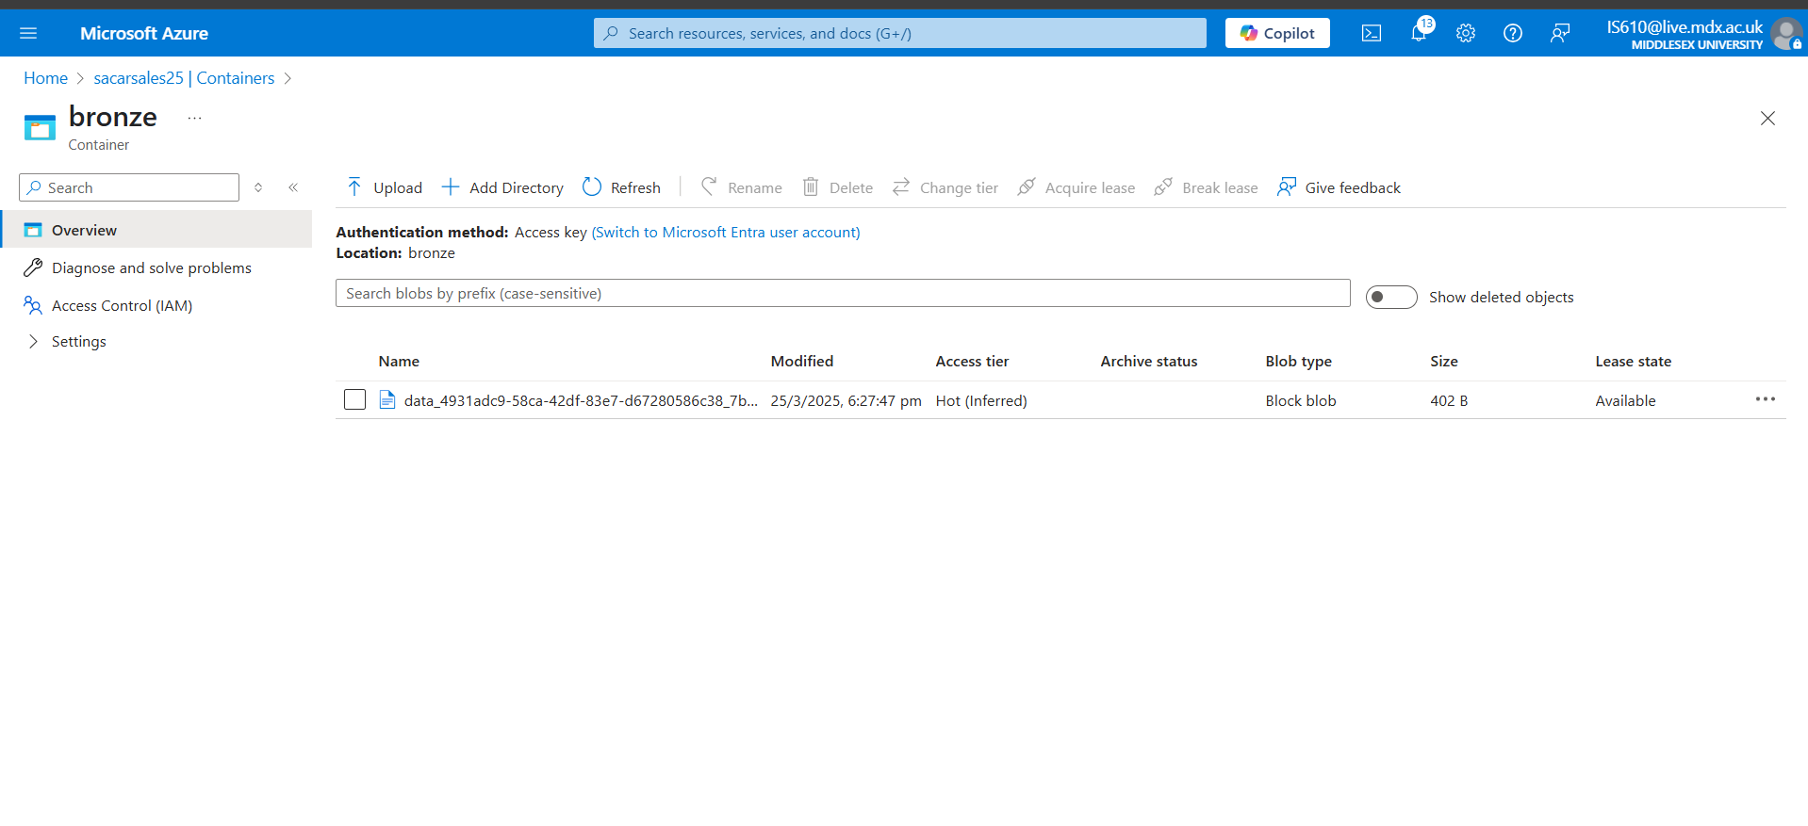

To check of the incremental load works:

Change the file name to Incrementalload.csv in the [copy_git_to_sqldb] pipeline

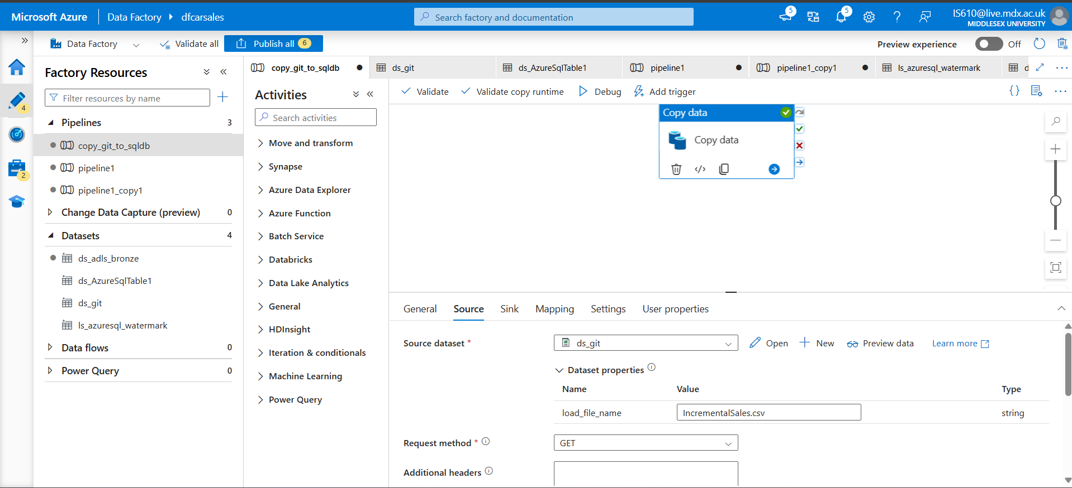

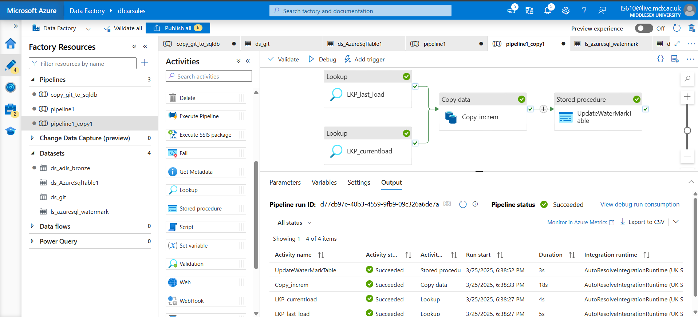

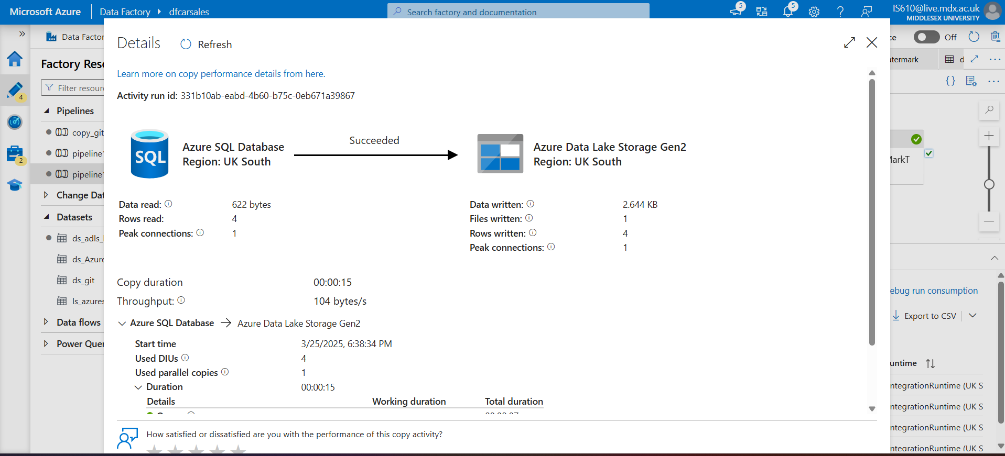

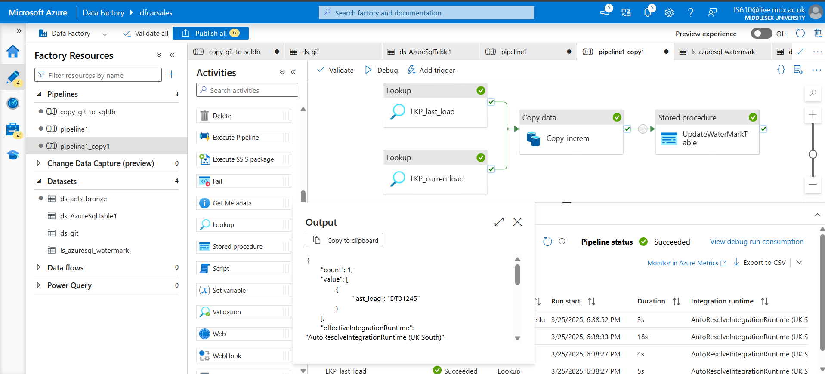 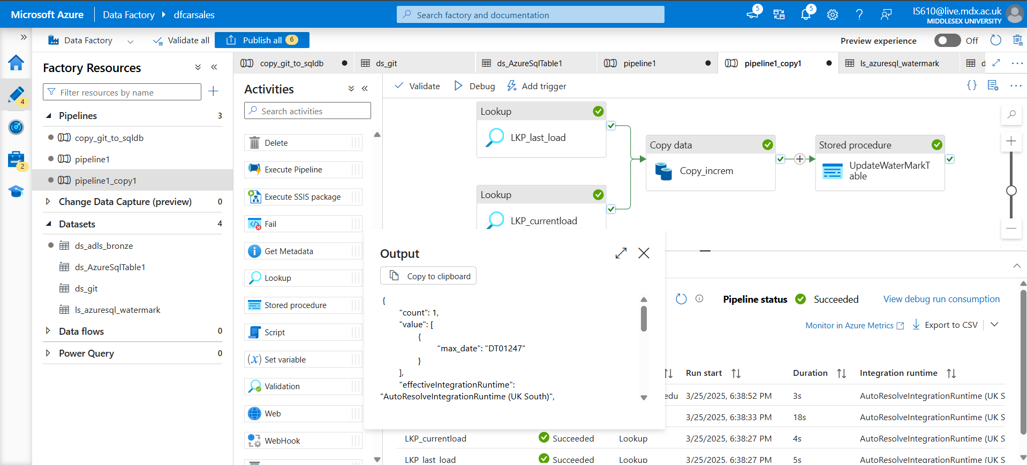

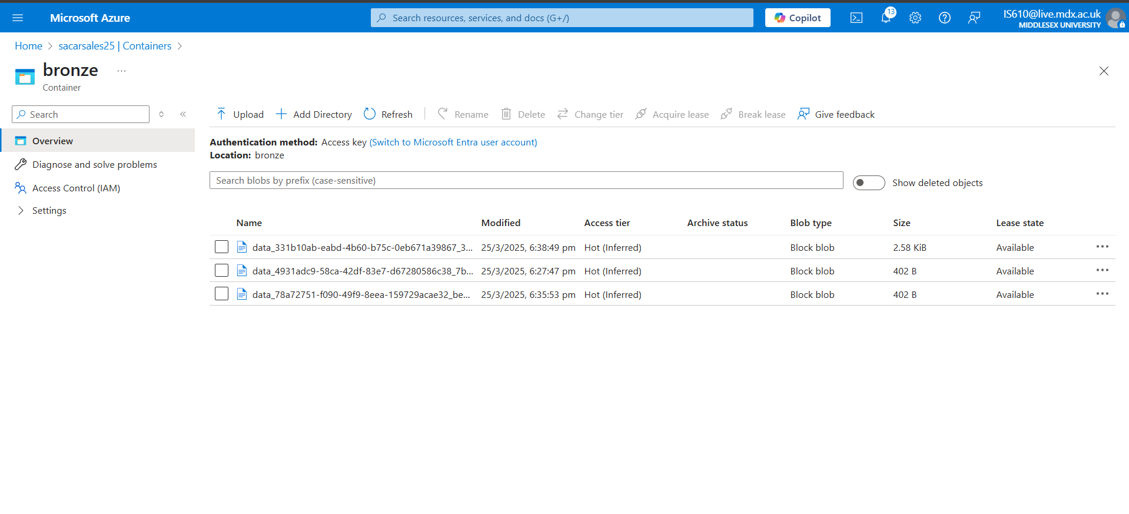

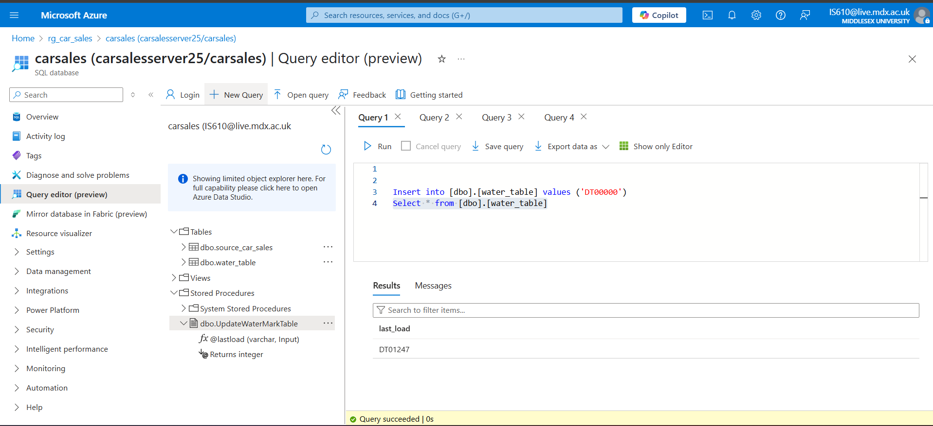

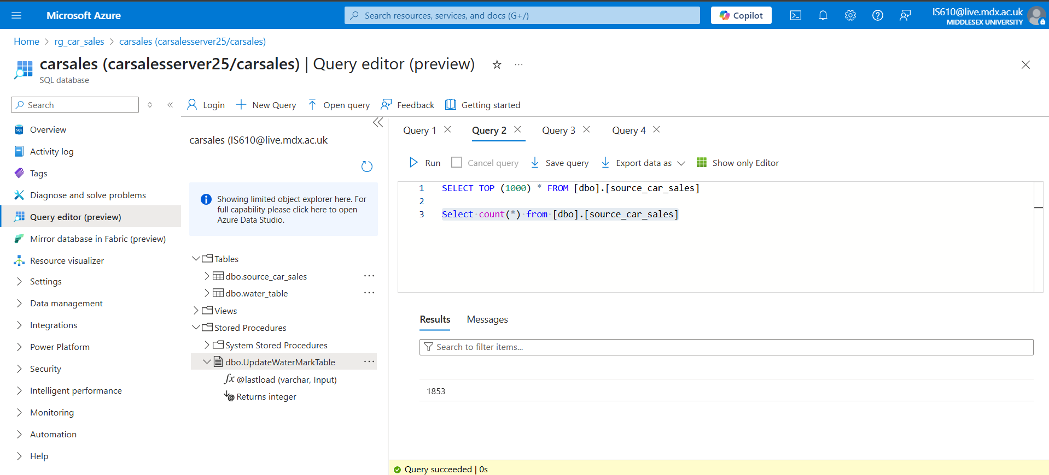

Earlier the counter was 1849, after incremental load, we got the counter as 1853.

## Step 4: Creating databricks resources

The Azure databricks workspace will have the following notebooks -

1. To setup the mountpoints
2. Bronze to silver
3. Silver to gold (dimensions and facts table)

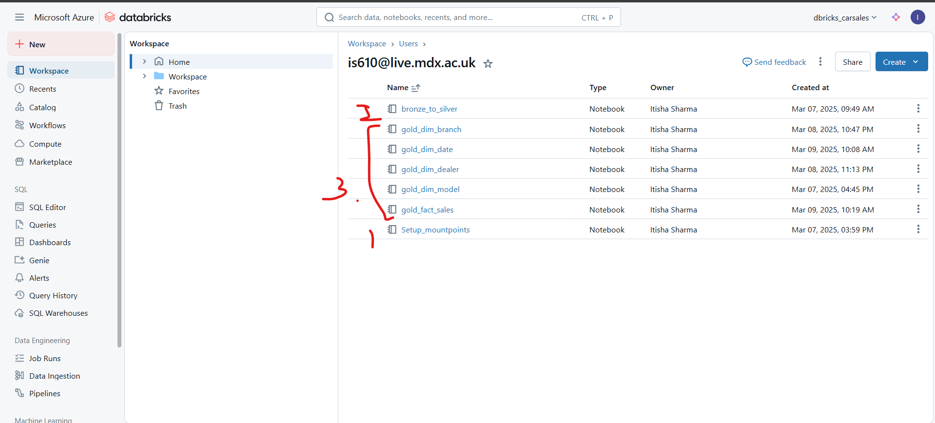

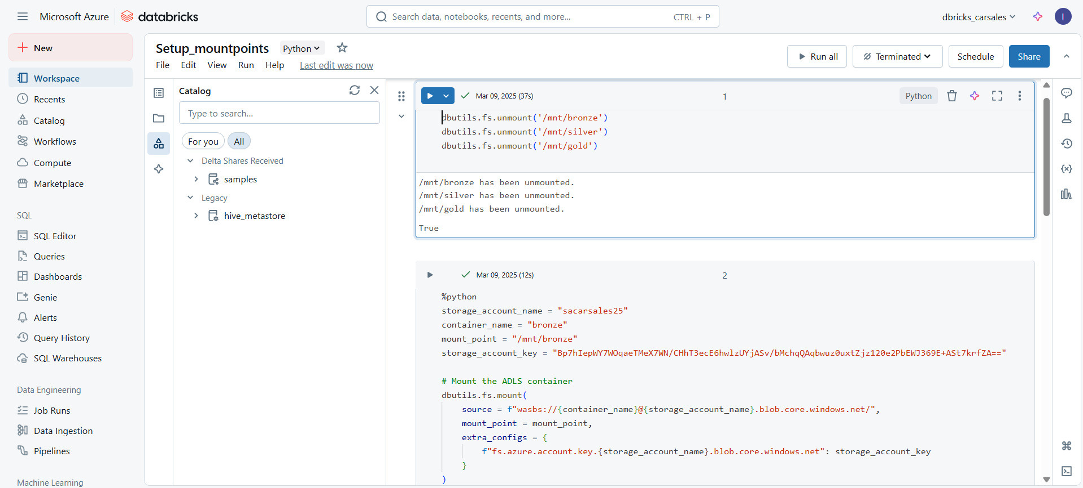

To get the storage account key: Go to Resource Group 🡪 storage account 🡪 Security_Networking 🡪 Access Keys 🡪 Copy the keys

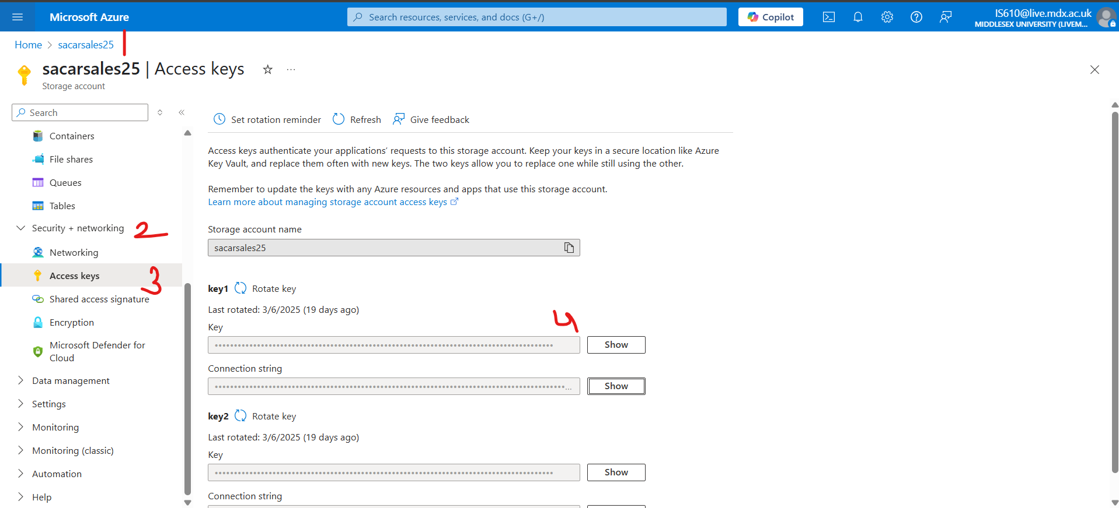

Inorder to create [gold_dim_branch/date//dealer/model ], the logic we follow is as follows:

* Load the files from /mnt/silver 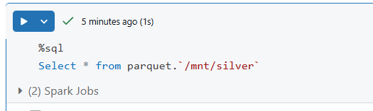
* Select distinct values and convert to dataframe . This is the source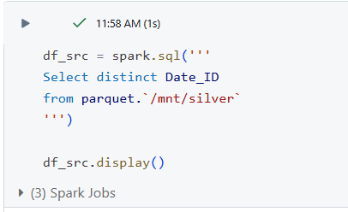
* Creating sink for incremental and initial load
* 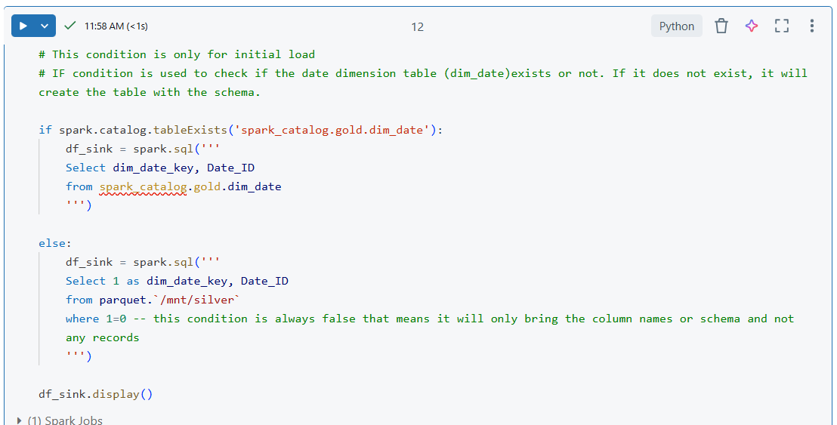
* 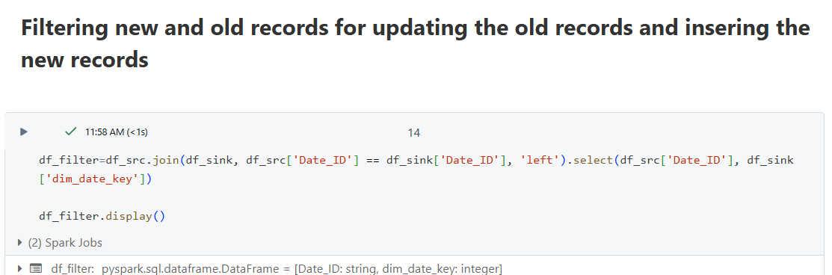 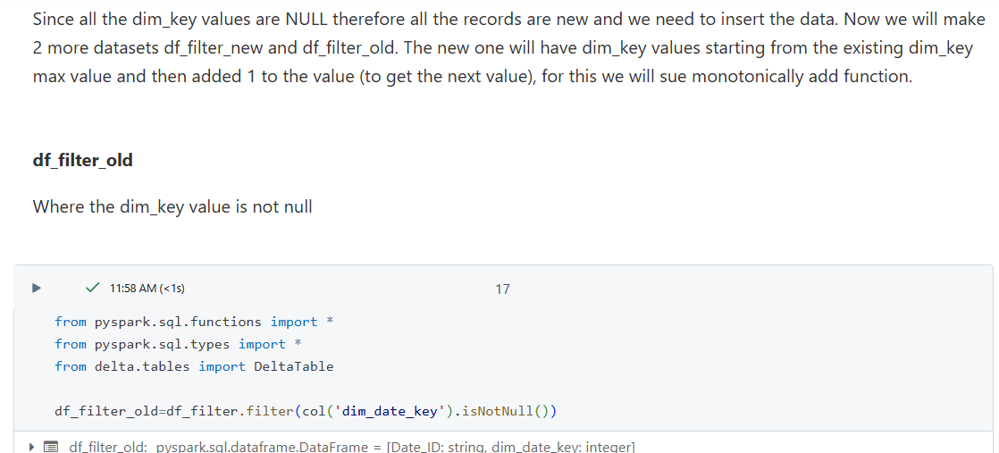 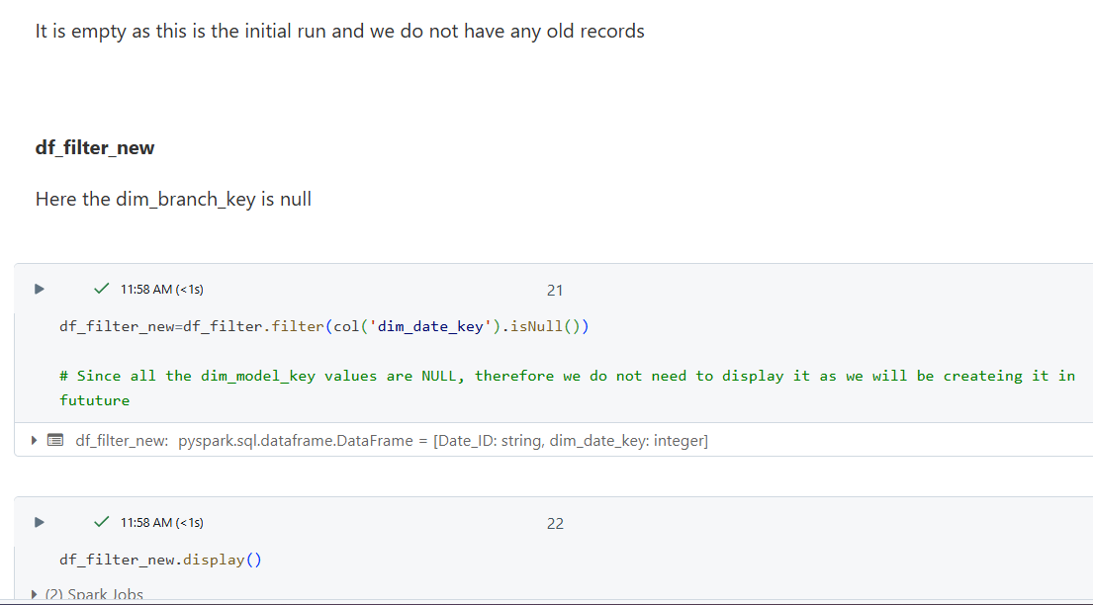 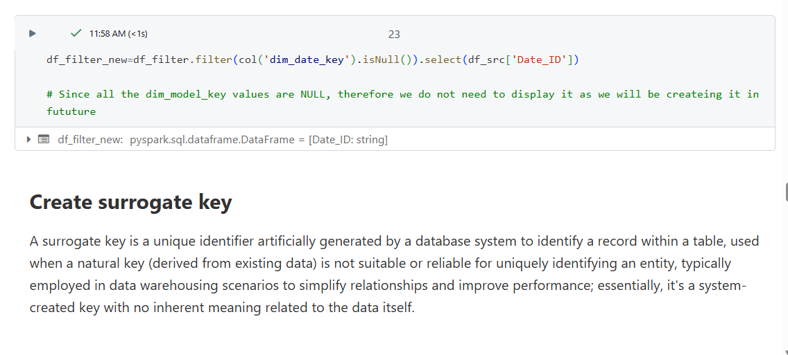 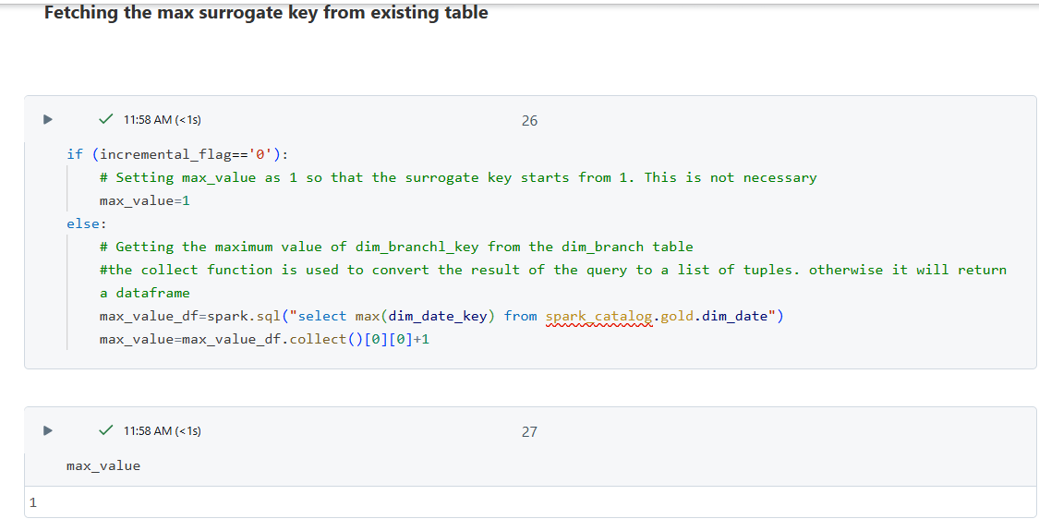 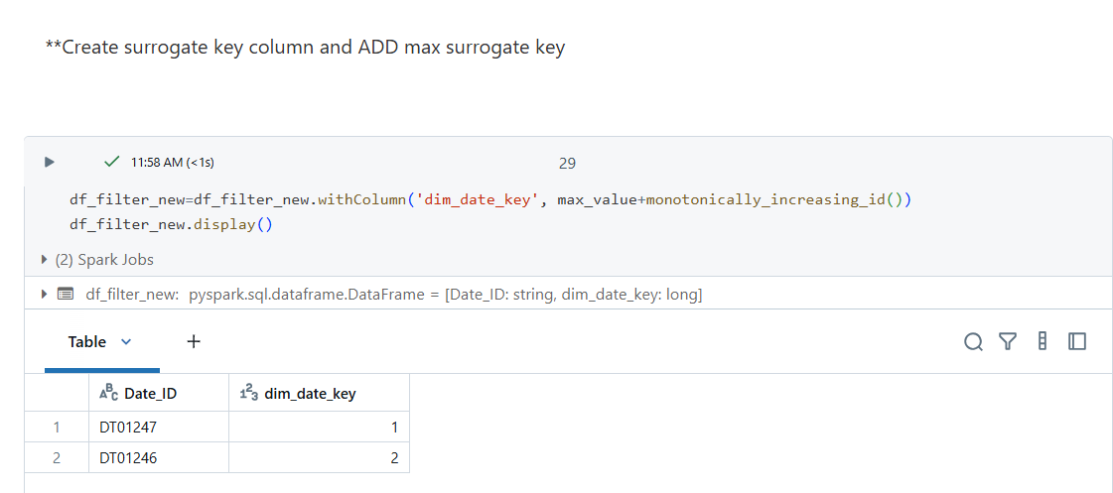 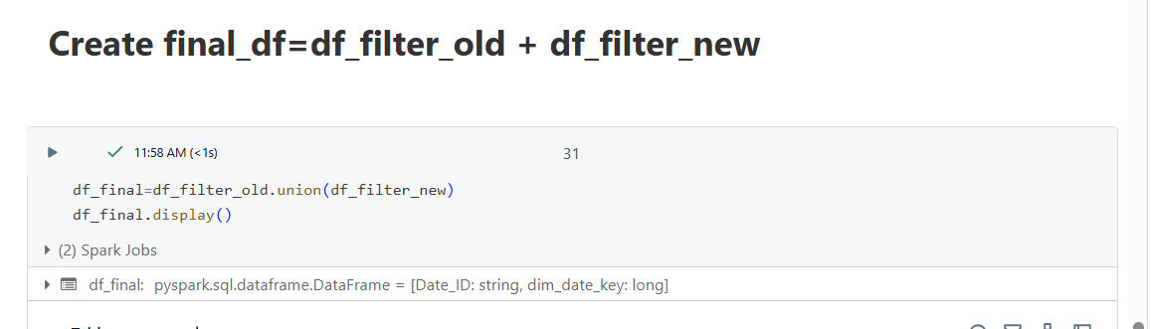
* SCD Type 1:
* 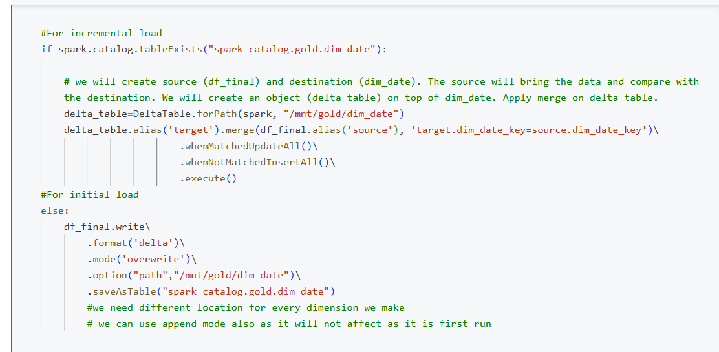

Creating the fact_sales

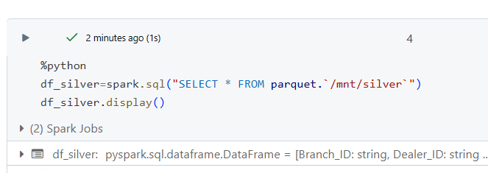 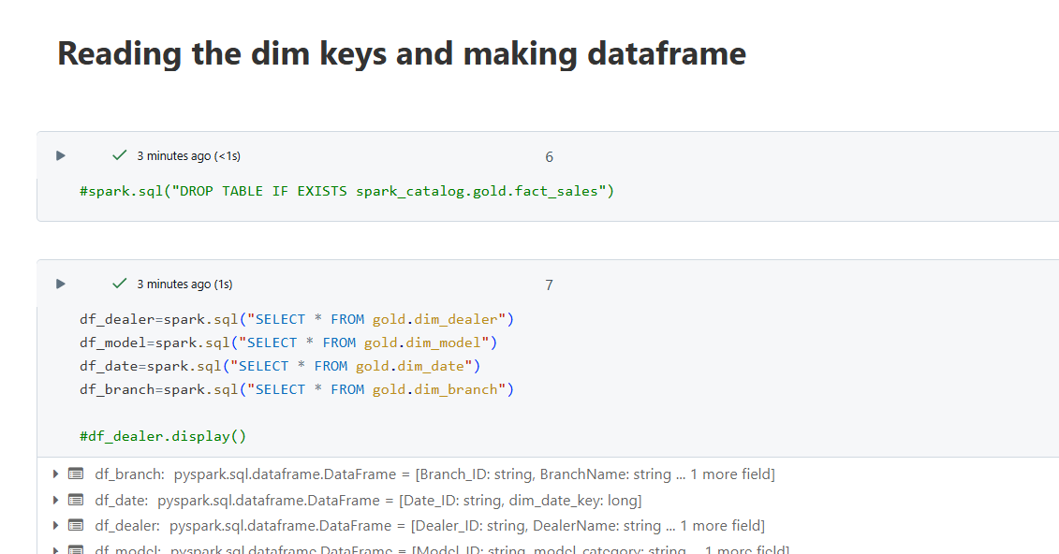 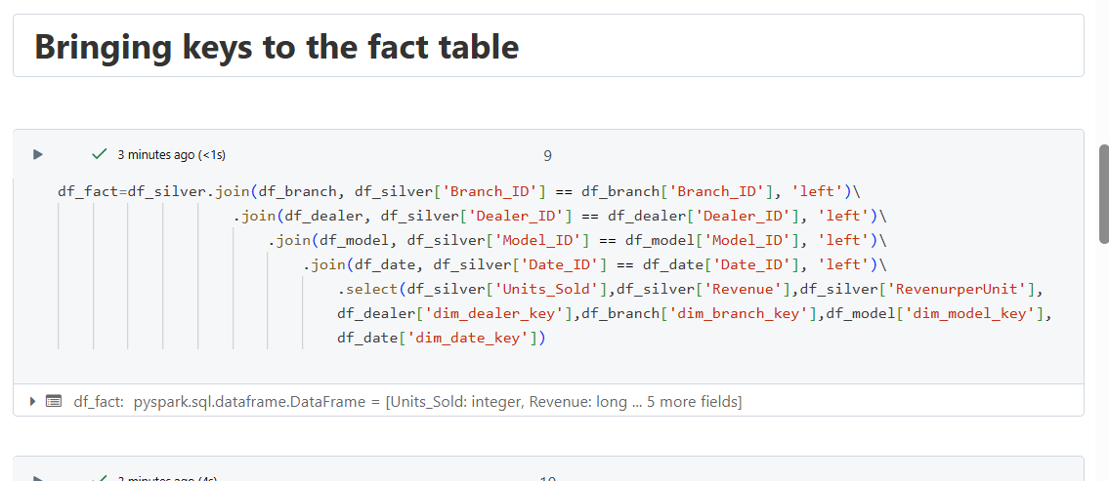 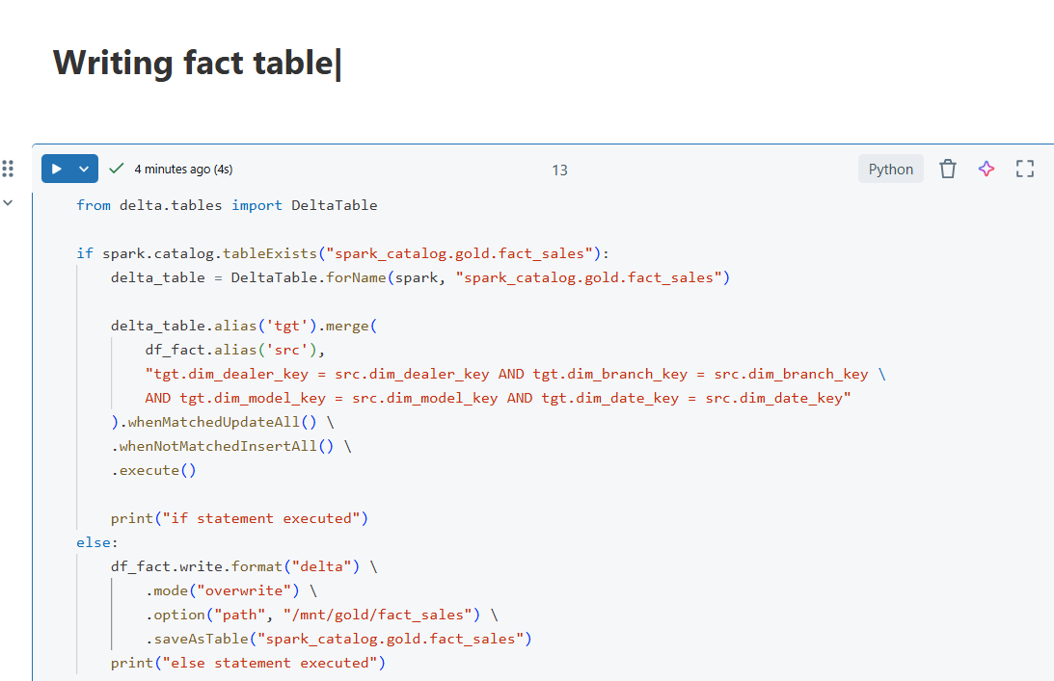 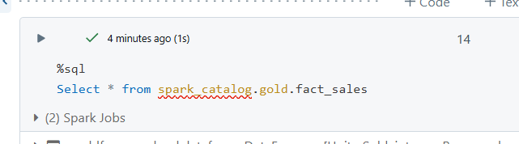

‘

We can also create a workflow in databricks

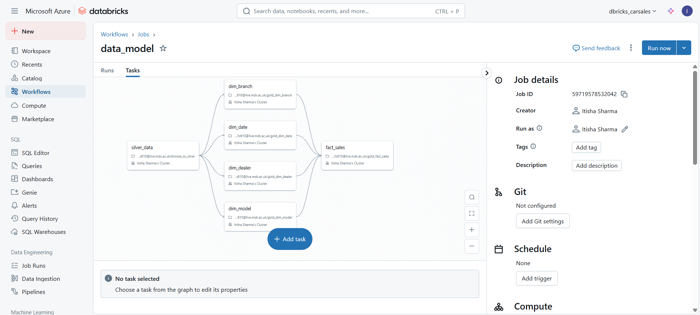

IN databricks –set the incremental load as 1

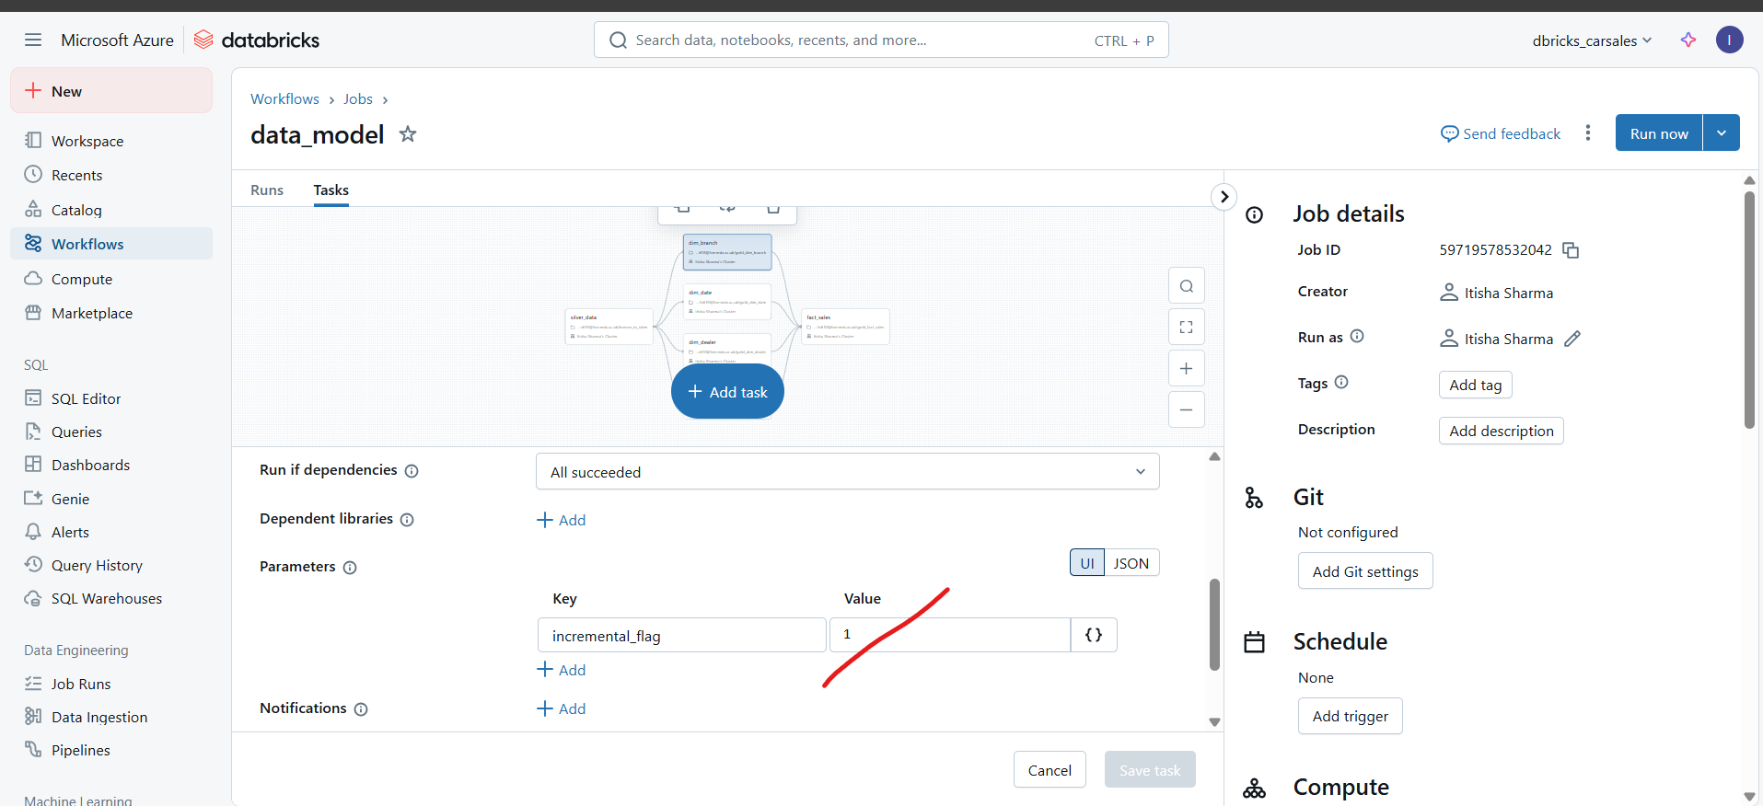

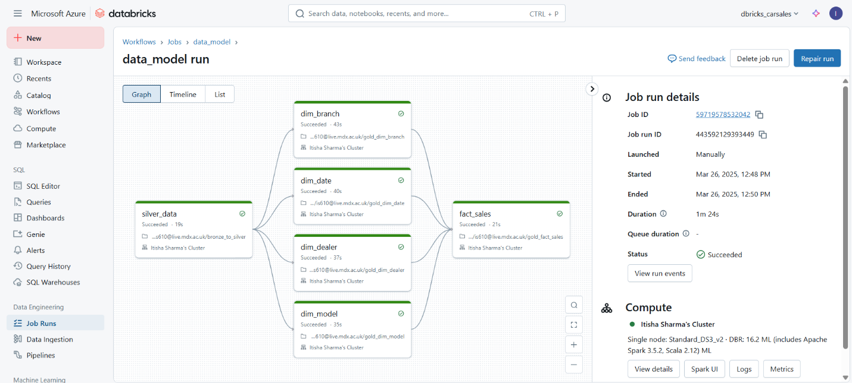

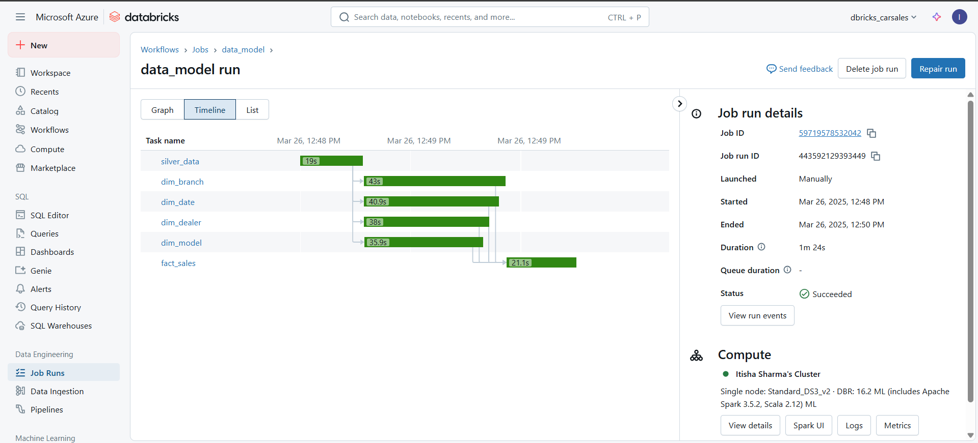

Azure pipeline will look like this

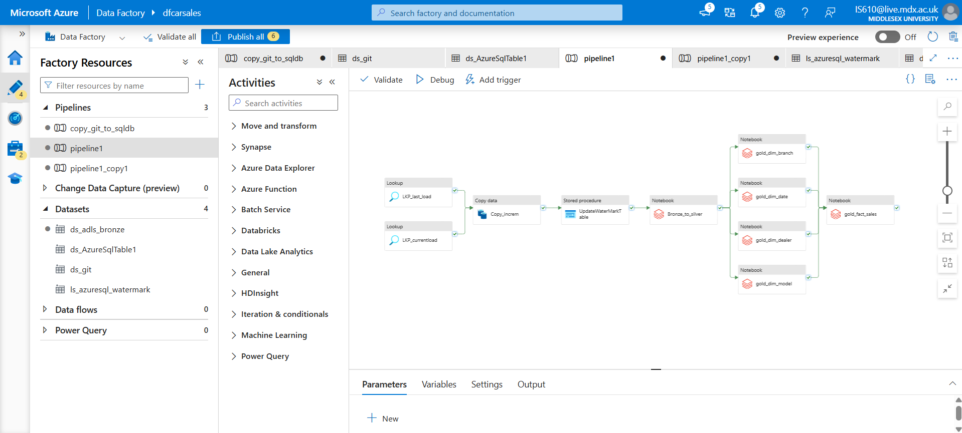

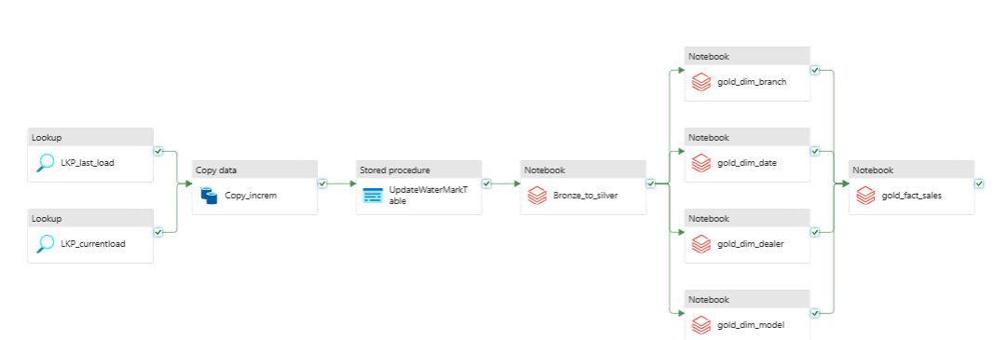

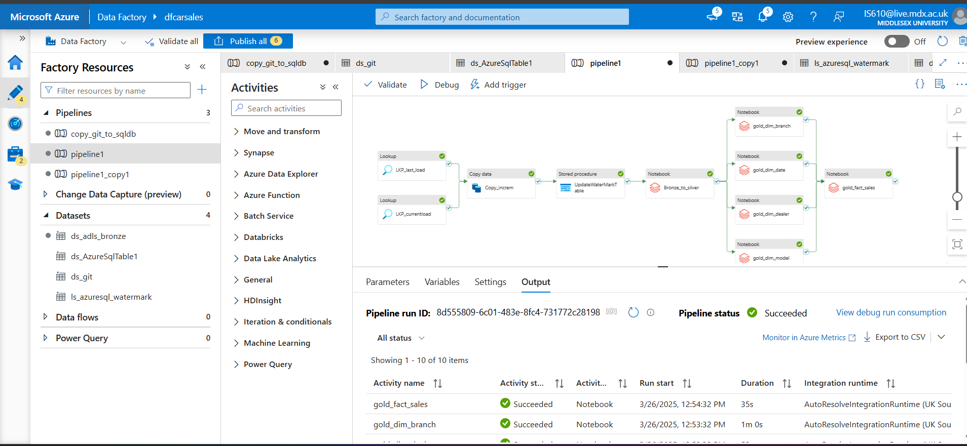

Final output 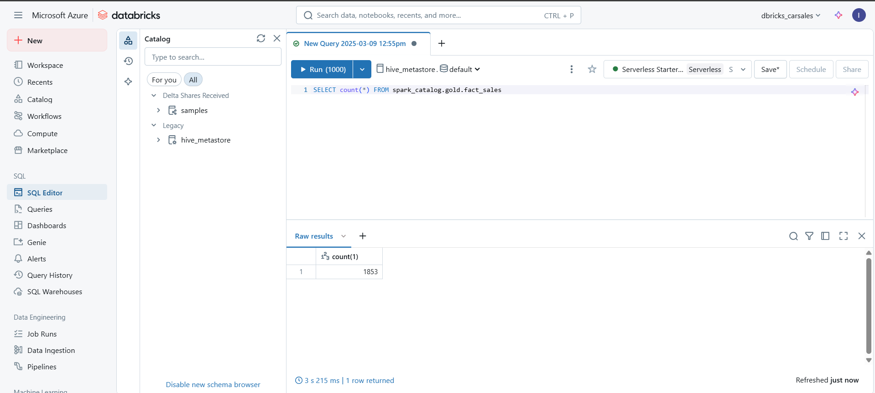

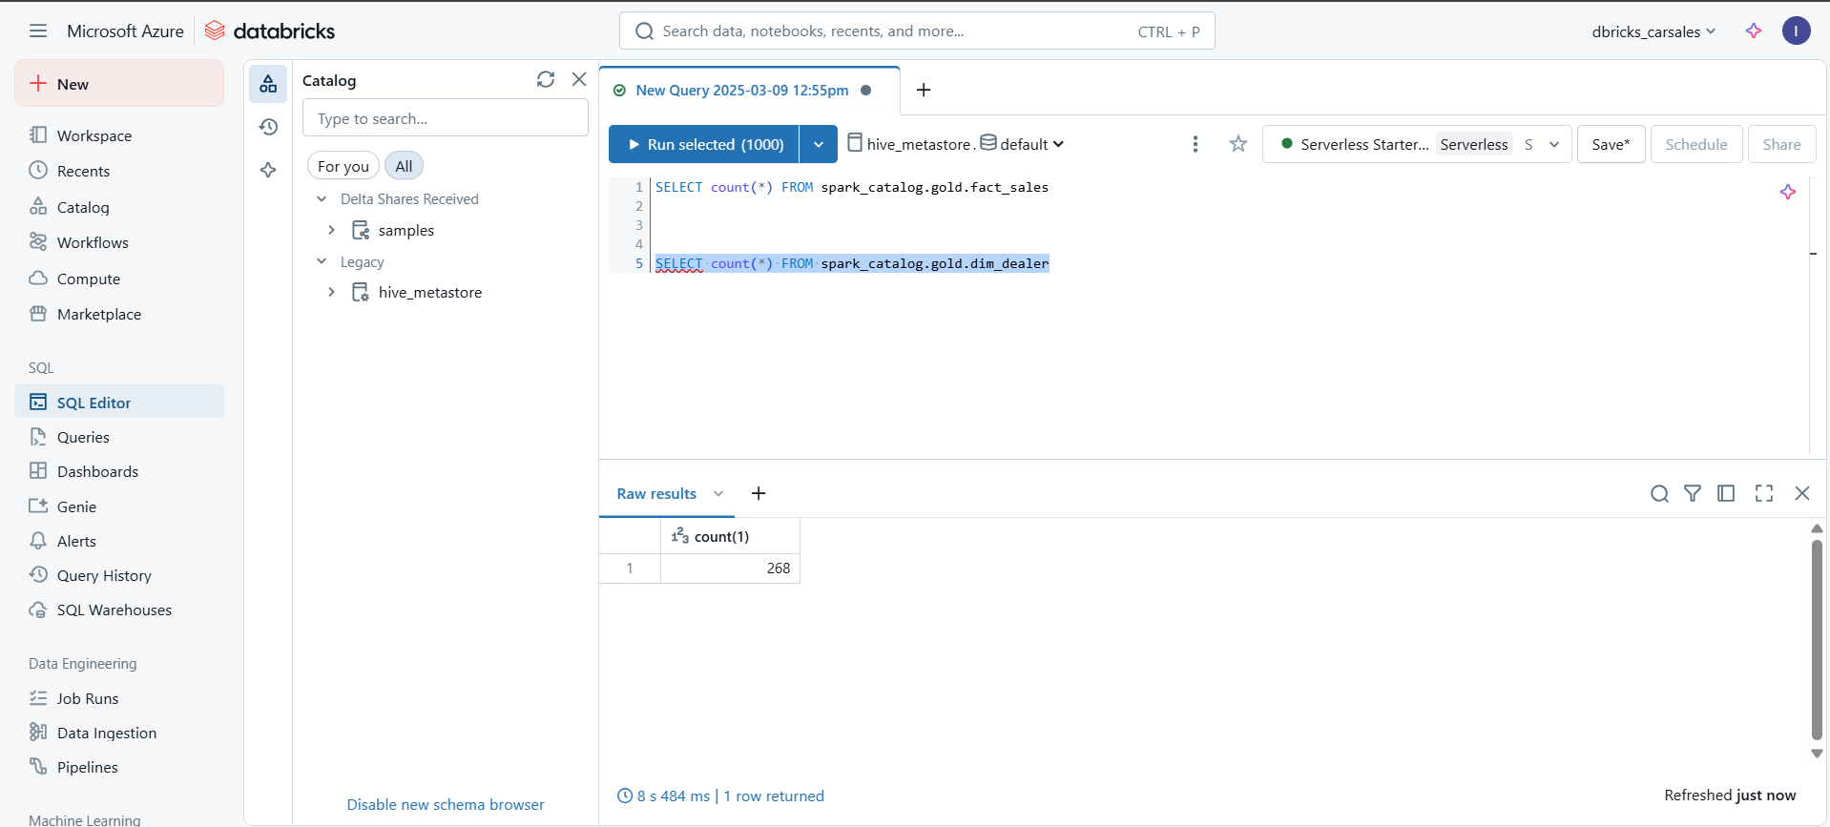

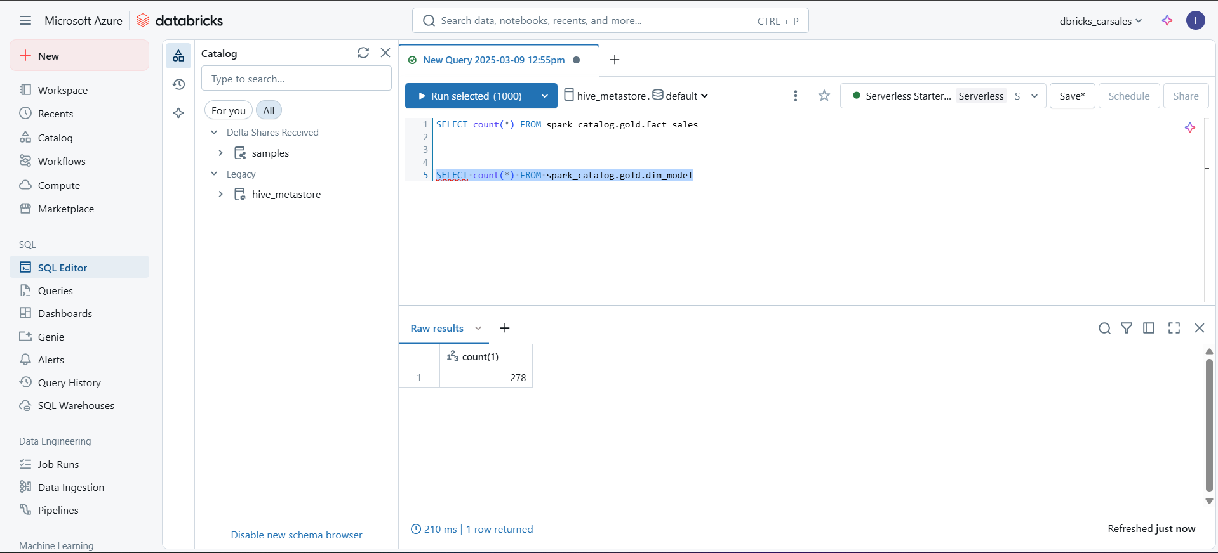

## Errors and resolutions

* Make sure that the copy_git_tosql pipeline is ran with Incremental_sales.scsv to ensure we have incremental data
* Always set the value of last_load –‘DT00000’ before running it for the first time

I got error at fact_Sales table, so I had to remove the duplicates

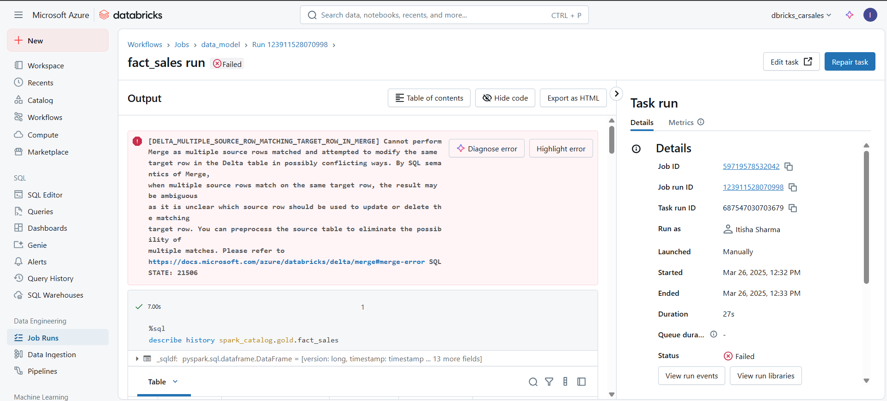

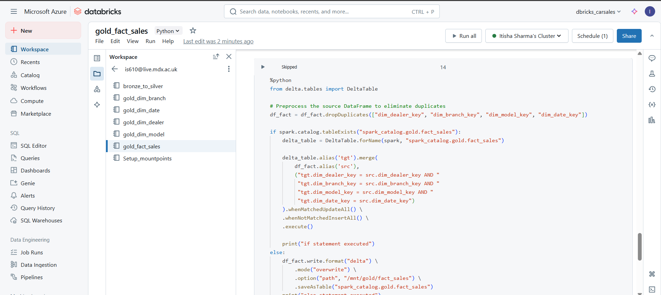

I got the following error because I tried to run parallel pipelines in databricks workflow and ADF pipeline

